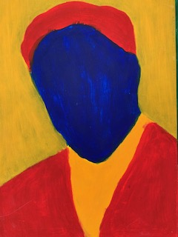

Foundation Stage

Paint can be applied evenly and with some accuracy to create a finished product representing something from the real world.

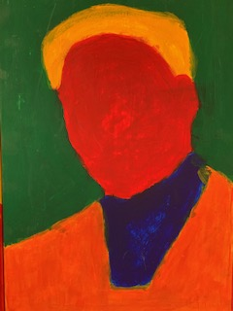

Year 1

Children are beginning to mix the primary colours (red, yellow and blue) to create secondary colours (green, orange and purple).

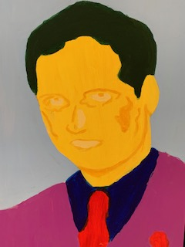

Year 2

Paint can be applied accurately and consistently and includes some emergent highlights and lowlights, which represents depth in the real world.

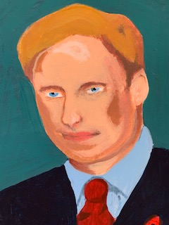

Year 3

Consistent and accurate painting coupled with a growing understanding of depth and tone results in a
sophisticated representation of the real world.
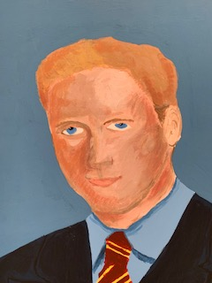

Year 4

Consistent and accurate painting coupled with a deeper understanding of depth and tone results in a
sophisticated representation of the real world with increasing independence.
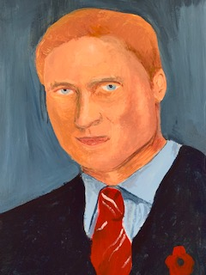

Year 5

Observational painting is accurate with highlights and lowlights used to create increasingly convincing depth, texture and realism.

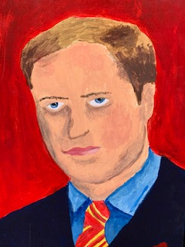

Year 6

Painting evidences convincing scale, texture and tone through the majority of a piece.

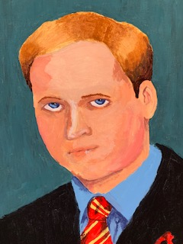

Mastery

Painting evidences convincing scale, depth, texture and tone throughout a piece.

