Quadrilaterals
Square

Rectangle

Rhombus

Kite

Parallelogram

Trapezium

Triangles
Right-angled triangle

Equilateral

Isosceles

Scalene

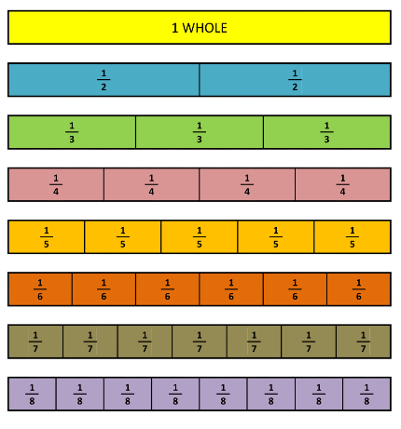
Key Vocabulary
Term | Definition | Example
Integer | A number which is not a fraction; a whole number. | 1, 2, 3, 4, 5 …
Positive | Any number above 0 | 1, 2, 3, 4, 5 …
Negative | Any number below 0 | -1, -2, -3, -4, -5 …
Multiple | A number in another number’s times table. | Multiples of 9 are  9, 18, 27, 36 …
Product | A quantity obtained by multiplying quantities together. | 3 x 4 = 12  5 x 7 = 35
Factor | A factor is a term that is a part of another term when multiplied. | Factors of 8 are 1 x 8, 2 x 4.
Quotient | Quotient is the result you get when you divide one number by another number. | When you divide 10 by 5, the number 2 is the example of the quotient.

Measures Conversions
1.3 kilometre (km) | 1300 metres (m)
1.18 metre (m) | 118 centimetres (cm)
1.6 centimetre (cm) | 16 millimetres (mm)
1.08 Litre (L) | 1080 milliltres (ml)
1 ¼ Kilogram (kg) | 1250 grams (g)
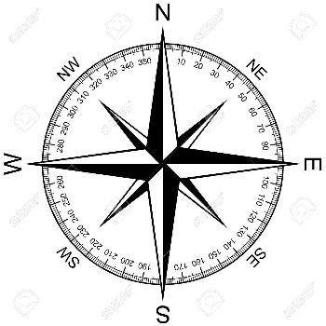

2D shapes
Quadrilateral | 4
Pentagon | 5
Hexagon | 6
Octagon | 8
Nonagon | 9
Decagon | 10
Polygon = shape with straight sides
Regular = all sides/angles the same
Irregular = sides/angles not same

Roman Numerals
I | V | X | L | C
1 | 5 | 10 | 50 | 100
VII | XIX | XLVII | LXVI | IC
7 | 19 | 47 | 66 | 99

Time conversion
3 ½ hours | 210 minutes
142 minutes | 2 hours 22 minutes
4 minutes | 240seconds
7 ½ years | 90 months
6 weeks | 42 days
18:24 | 6:24pm
05:15 | 5:15am

Types of Angles
Acute angle | Right angle | Reflex angle | Obtuse angle | Straight angle
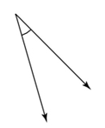 | 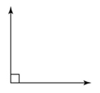 | 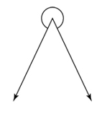 | 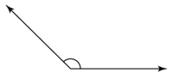 | 