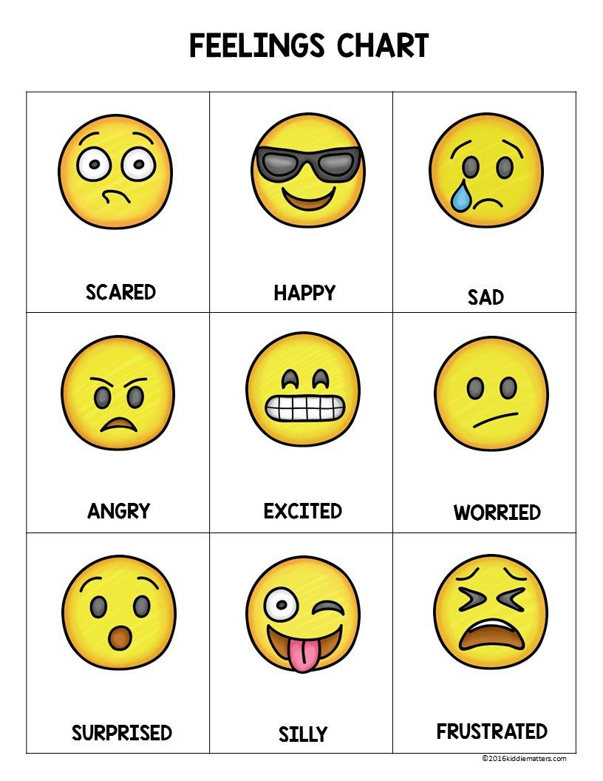
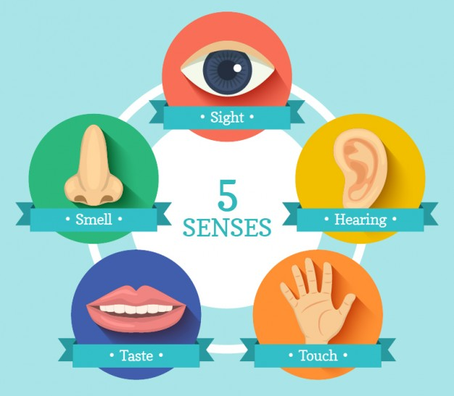
Key Vocabulary
Humans | A man, woman or child that is different to animals.
Body | Physical parts of us including head, arms and legs.
Senses | What we use to understand the world.
Skeleton | The frame of bones supporting our body.
Germs | A very small living thing that can make you ill.
Family | A group of people who share a bond.
