Key Vocabulary | Definition
Human Rights | A right which is believed to belong to every person
Justice | Just behaviour or treatment
Freedom | The state of not being imprisoned or enslaved.
Injustice | Lack of fairness or justice.
Forgiveness | The action or process of forgiving or being forgiven.
Reconcilliation | The restoration of friendly relations
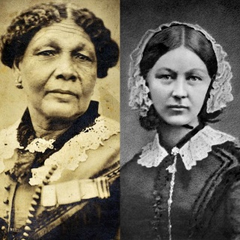
Key People – Crimean War
Florence Nightingale | A nurse during the Crimean War, who cared for the soldiers and made significant changes to how the hospitals were ran. Also known as ‘The Lady with the Lamp’.
Mary Seacole | Mary Jane Seacole 1805 – 1881 was a British-Jamaican business woman and nurse who set up the "British Hotel" behind the lines during the Crimean War. She described this as "a mess-table and comfortable quarters for sick and convalescent officers."
Lord Raglan - Earl of Cardigan, | Led the Charge of the Light Brigade during the Battle of Balaclava. He is generally recognised for his bravery in leading the charge, despite little chance of succeeding.

Key Locations
Official Name: Russian Federation | Official Name: United States of America (U.S.A)
Capital: Moscow | Capital: Washington
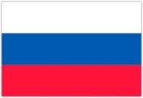  Official Language: Russian | Official Language: English
Money: Ruble | 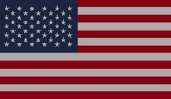  Money: Dollar
As the world’s largest country, Russia occupies one-tenth of all the land on Earth. It spans 11 time zones across two continents (Europe and Asia) and has shores on three oceans (the Atlantic, Pacific and Arctic Ocean). The Russian landscape varies from vast deserts to frozen coastline, tall mountains to giant marshes. Russia has around 100,000 rivers, including some of the longest and most powerful in the world. It also has many lakes, including Ladoga and Onega (Europe’s two largest lakes), and Lake Baikal, which contains more water than any other lake on Earth. | The United States of America is the world’s third largest country in size (after Russia and Canada) and the third largest in terms of population (after China and India). Located in North America, the country is bordered on the west by the Pacific Ocean, and on the east by the Atlantic Ocean. Along the northern border is Canada, and along the southern border is Mexico. There are 50 states and the District of Columbia. More than twice the size of the European Union, the United States has high mountains in the West and a vast, central plain. The lowest point in the country is in Death Valley, which sits 86m below sea level, and the highest peak is Mount McKinley, standing a whopping 6,198m tall.
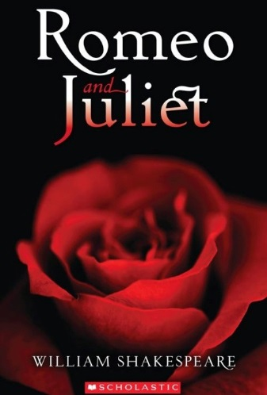
Key Concept/Features
Crimean War  October 1853 and February 1856. | The war was between Russia on one side and Britain, France, the Ottoman Empire (Turkey) and the Kingdom of Sardinia on the other.  The causes of the war and the reasons for conflict are really complex, but in general terms, it was about who would control the territories of the Ottoman Empire.
Cold War  1945 - 1991 | A state of political and military tension after World War 2 between powers in the Western Bloc (the United States) and powers in the Eastern Bloc (the Soviet Union). The term "cold" is used because there was no large-scale fighting directly between the two sides.
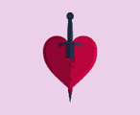  Text to be studied based upon Conflict – Romeo and Juliet by William Shakespeare | William Shakespeare (23 April 1564 – 23 April 1616) was an English poet, playwright and actor, widely regarded as the greatest writer in the English language. His plays were performed at The Globe theatre in London.  Romeo and Juliet is a classic story about how an age-old vendetta between two powerful families (Capulets and Montagues) erupts and causes conflict between them. A young lovesick Romeo Montague falls instantly in love with Juliet Capulet, much to the disapproval of their families.

