Curriculum Overview
 | Autumn Term | Spring Term | Summer Term
Year 1 | Roam Around Britain | Life Beside the Sea  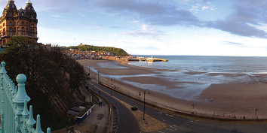 | Our Changing Planet
Year 2 | Fire! Fire!  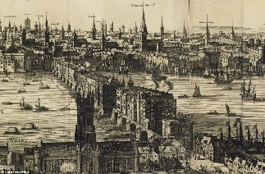 | Jet, Set, Go | The Time Machine
Year 3 | The Vikings are Here!  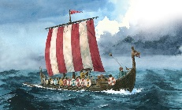 | Back to the 80’s | Tomb Raider  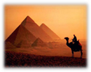
Year 4 | Scavengers and Settlers  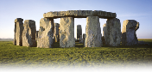 | Scrumdiddly-umptious  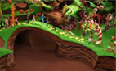 | Groovy Greeks  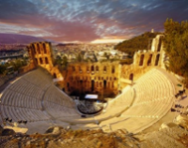
Year 5 | Let the Games Begin!  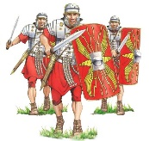 | Mundus Novus  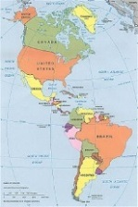 | To Infinity and Beyond
Year 6 | Conflict | Earth S.O.S | Children’s Choice  ?

