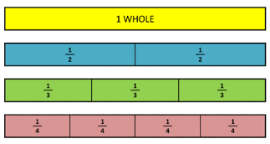
Key Vocabulary
Term | Definition | Example
Odd numbers | A whole number that cannot be divided by 2. | 1, 3, 5, 7, 9 …
Even numbers | A whole number that can divide by 2. | 2, 4, 6, 8 …
Multiple | A number in another number’s times table. | Multiples of 9 are  9, 18, 27, 36 …
Array | An array is a set of numbers or objects placed in rows or columns. | 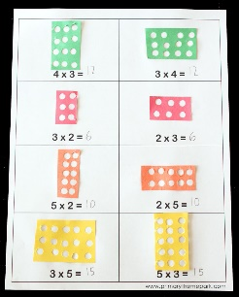
Symmetrical | Made up of exactly similar parts facing each other. | 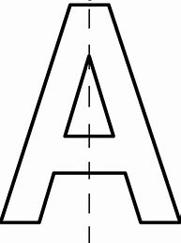
Measures Conversions
Length
1 kilometre (km) | 1000 metres (m)
1metre (m) | 100 centimetres (cm)
Capacity
1centimetre (cm) | 10 millimetres (mm)
1Litre (L) | 100 0milliltres (ml)
Mass
1 Kilogram (kg) | 1000 grams (g)
Month | Days
January | 31
February | 28 (29 in a leap year)
March | 31
April | 30
May | 31
June | 30
July | 31
August | 31
September | 30
October | 31
November | 30
December | 31
1 year = 365 days = 52 weeks
1 leap year = 366 days
Fortnight = 2 weeks

Time
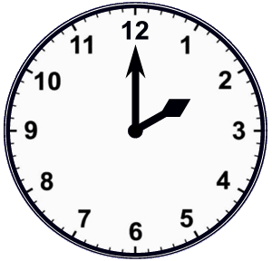 | 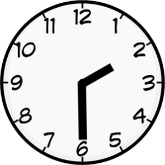 | 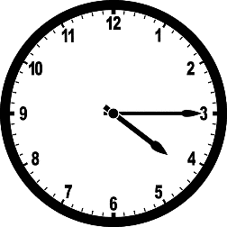 | 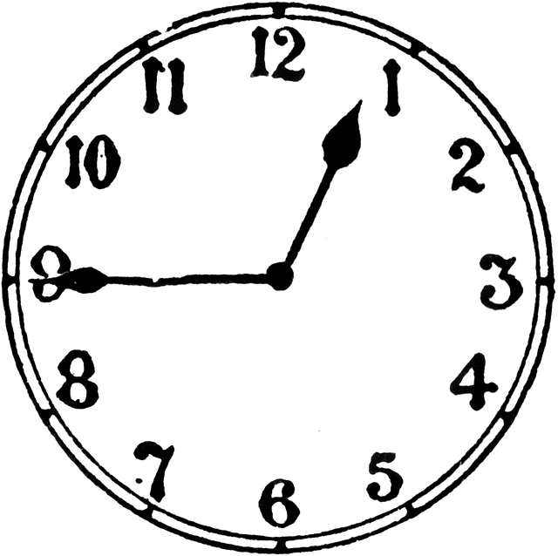
2 o’clock | Half past 2 | Quarter past 4 | Quarter to 1

3d shapes |  | Faces | Edges | Vertices
Cuboid |  | 6 | 12 | 8
Sphere |  | 1 | 0 | 0
Hemi-sphere | 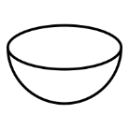 | 2 | 1 | 0
Cylinder | 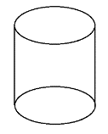 | 3 | 2 | 0
Square-based Pyramid | 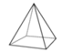 | 5 | 8 | 5

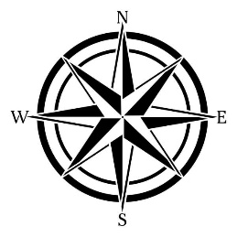
2D shapes
Shape | Number of sides
Pentagon | 5
Hexagon | 6
Heptagon | 7
Octagon | 8
