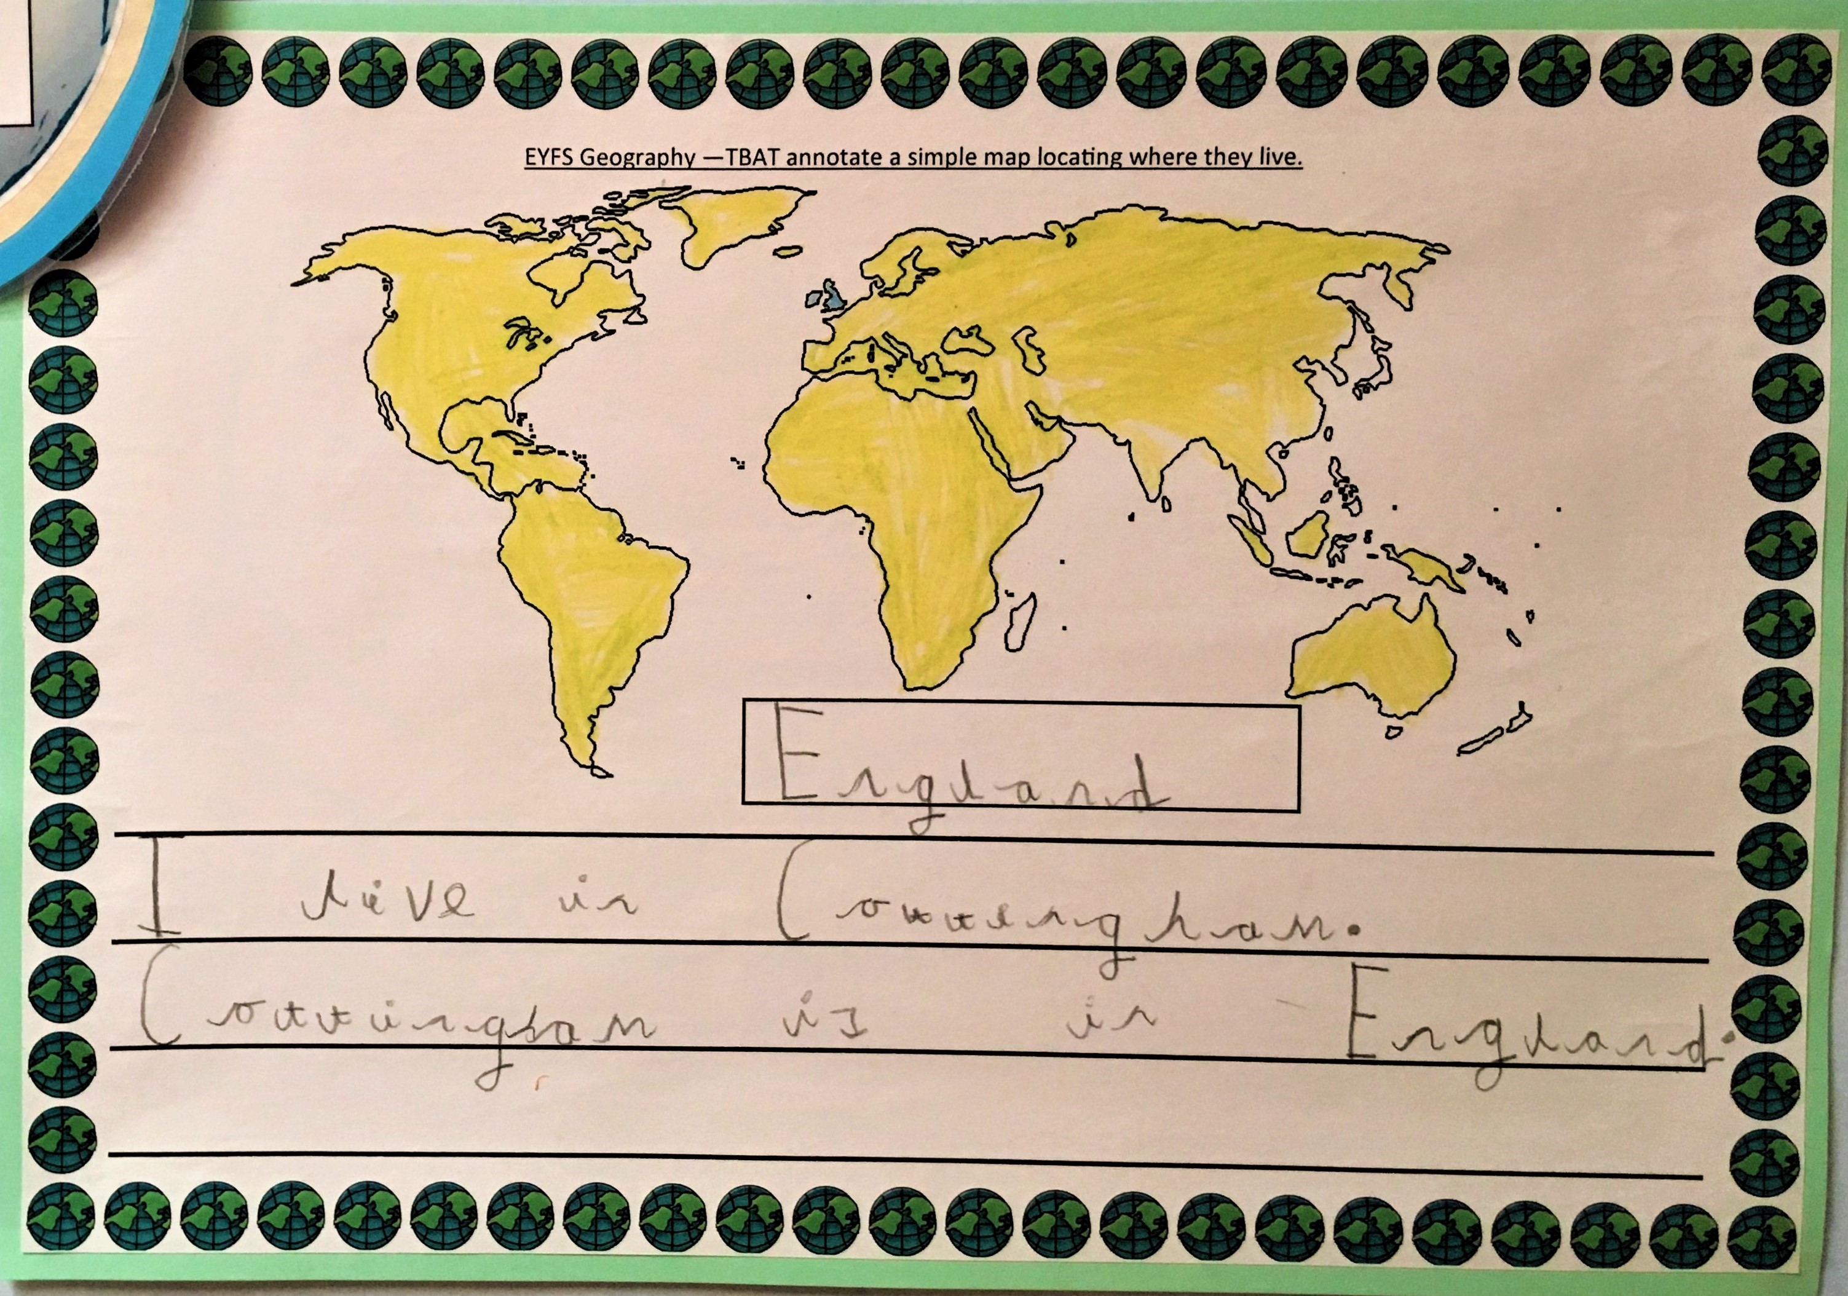
Foundation stage:
Children can identify on a map where they live in relation to the world.

Key Vocabulary
Map, World, England

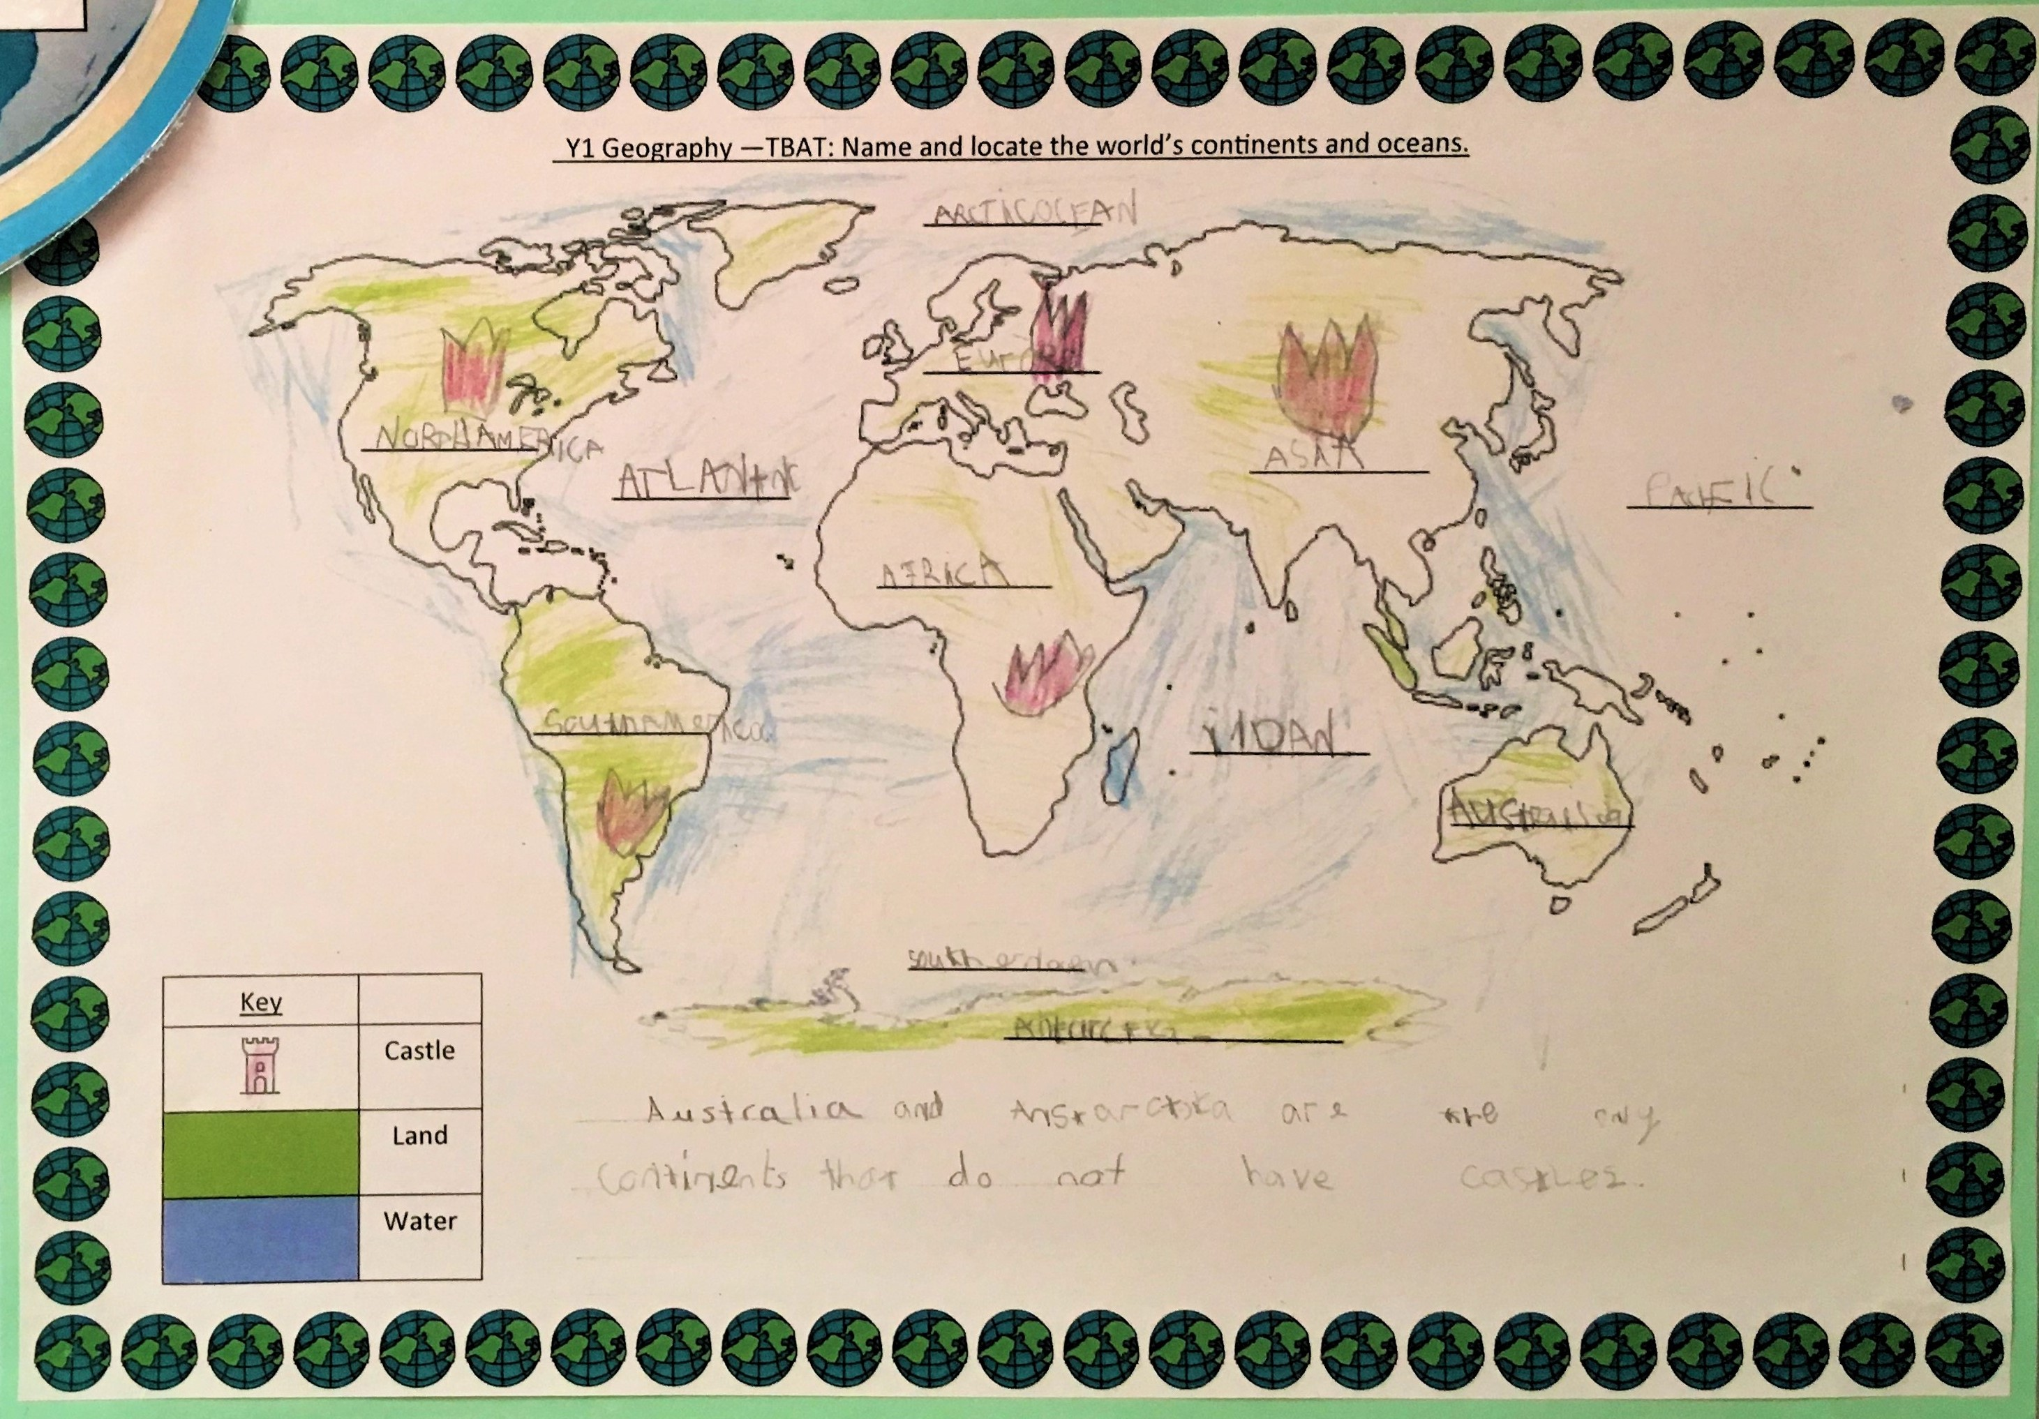
Year 1:
Children look closely at our world and identify the seven continents and the five oceans. They can label these on a map.

Key Vocabulary
Continent, Ocean

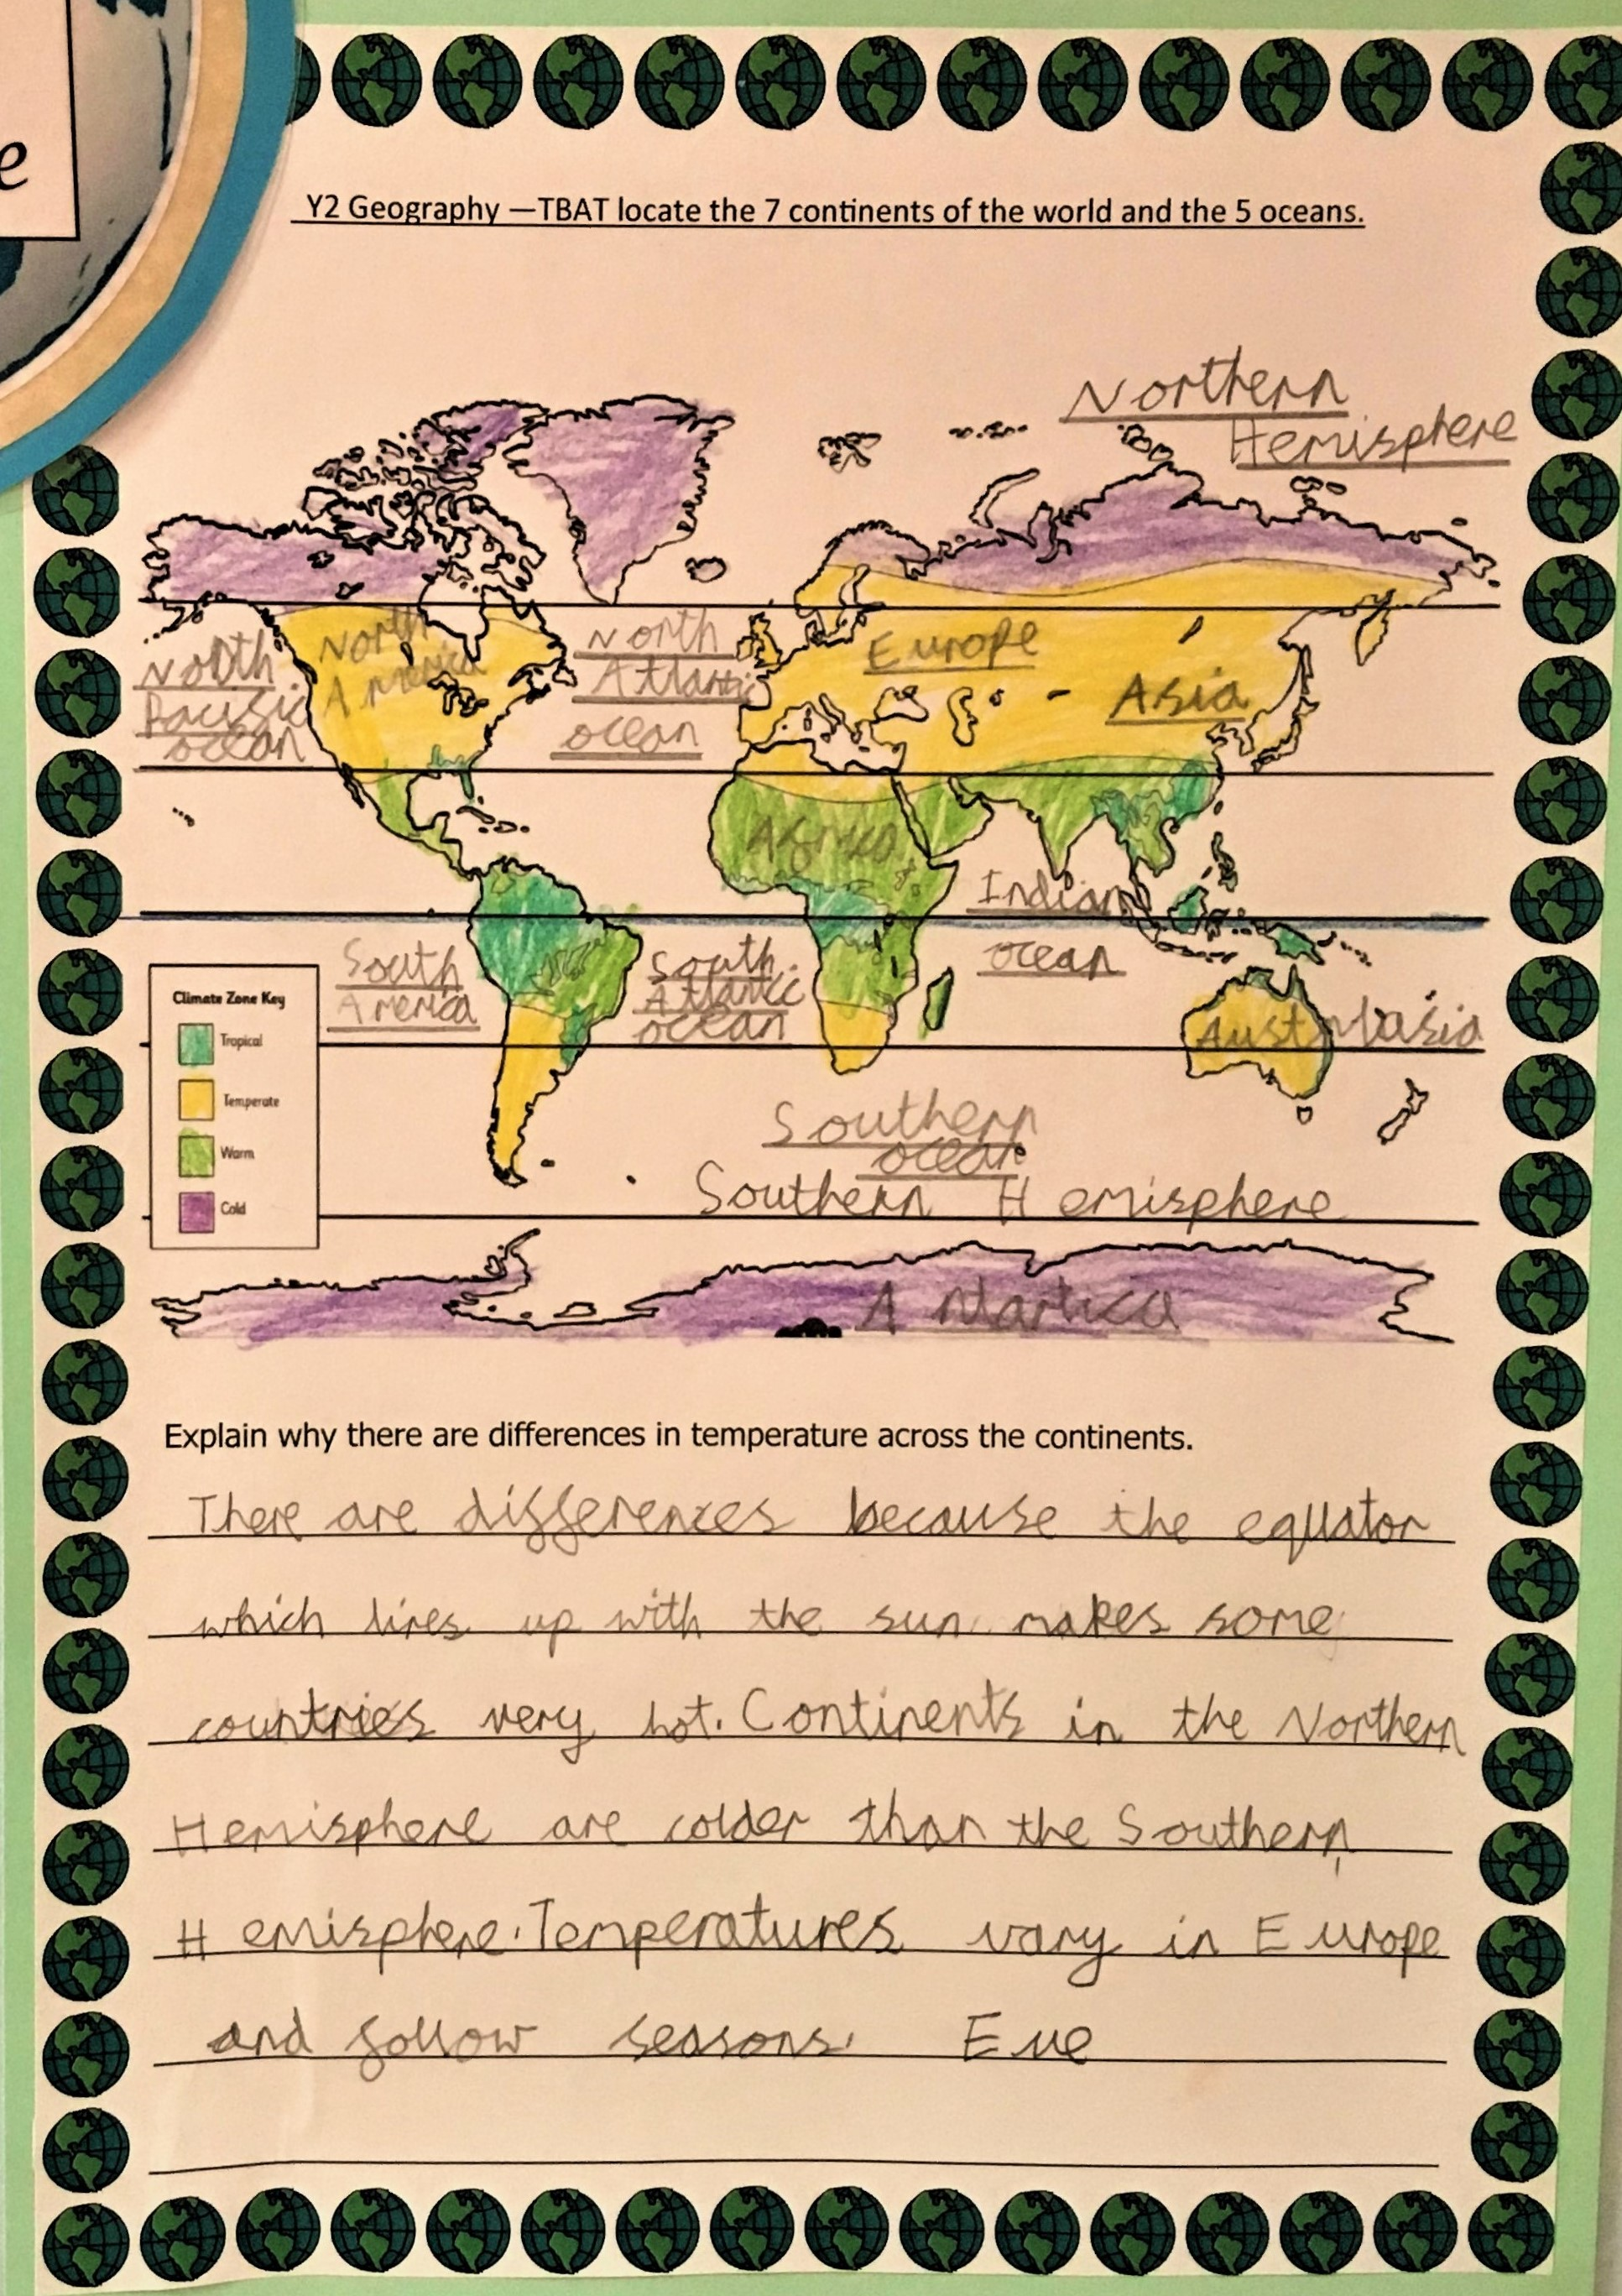

Year 2:
Children can confidently identify the seven continents and the five oceans, looking more closely at our world and its differences between continents.

Key Vocabulary
Equator, Hemisphere

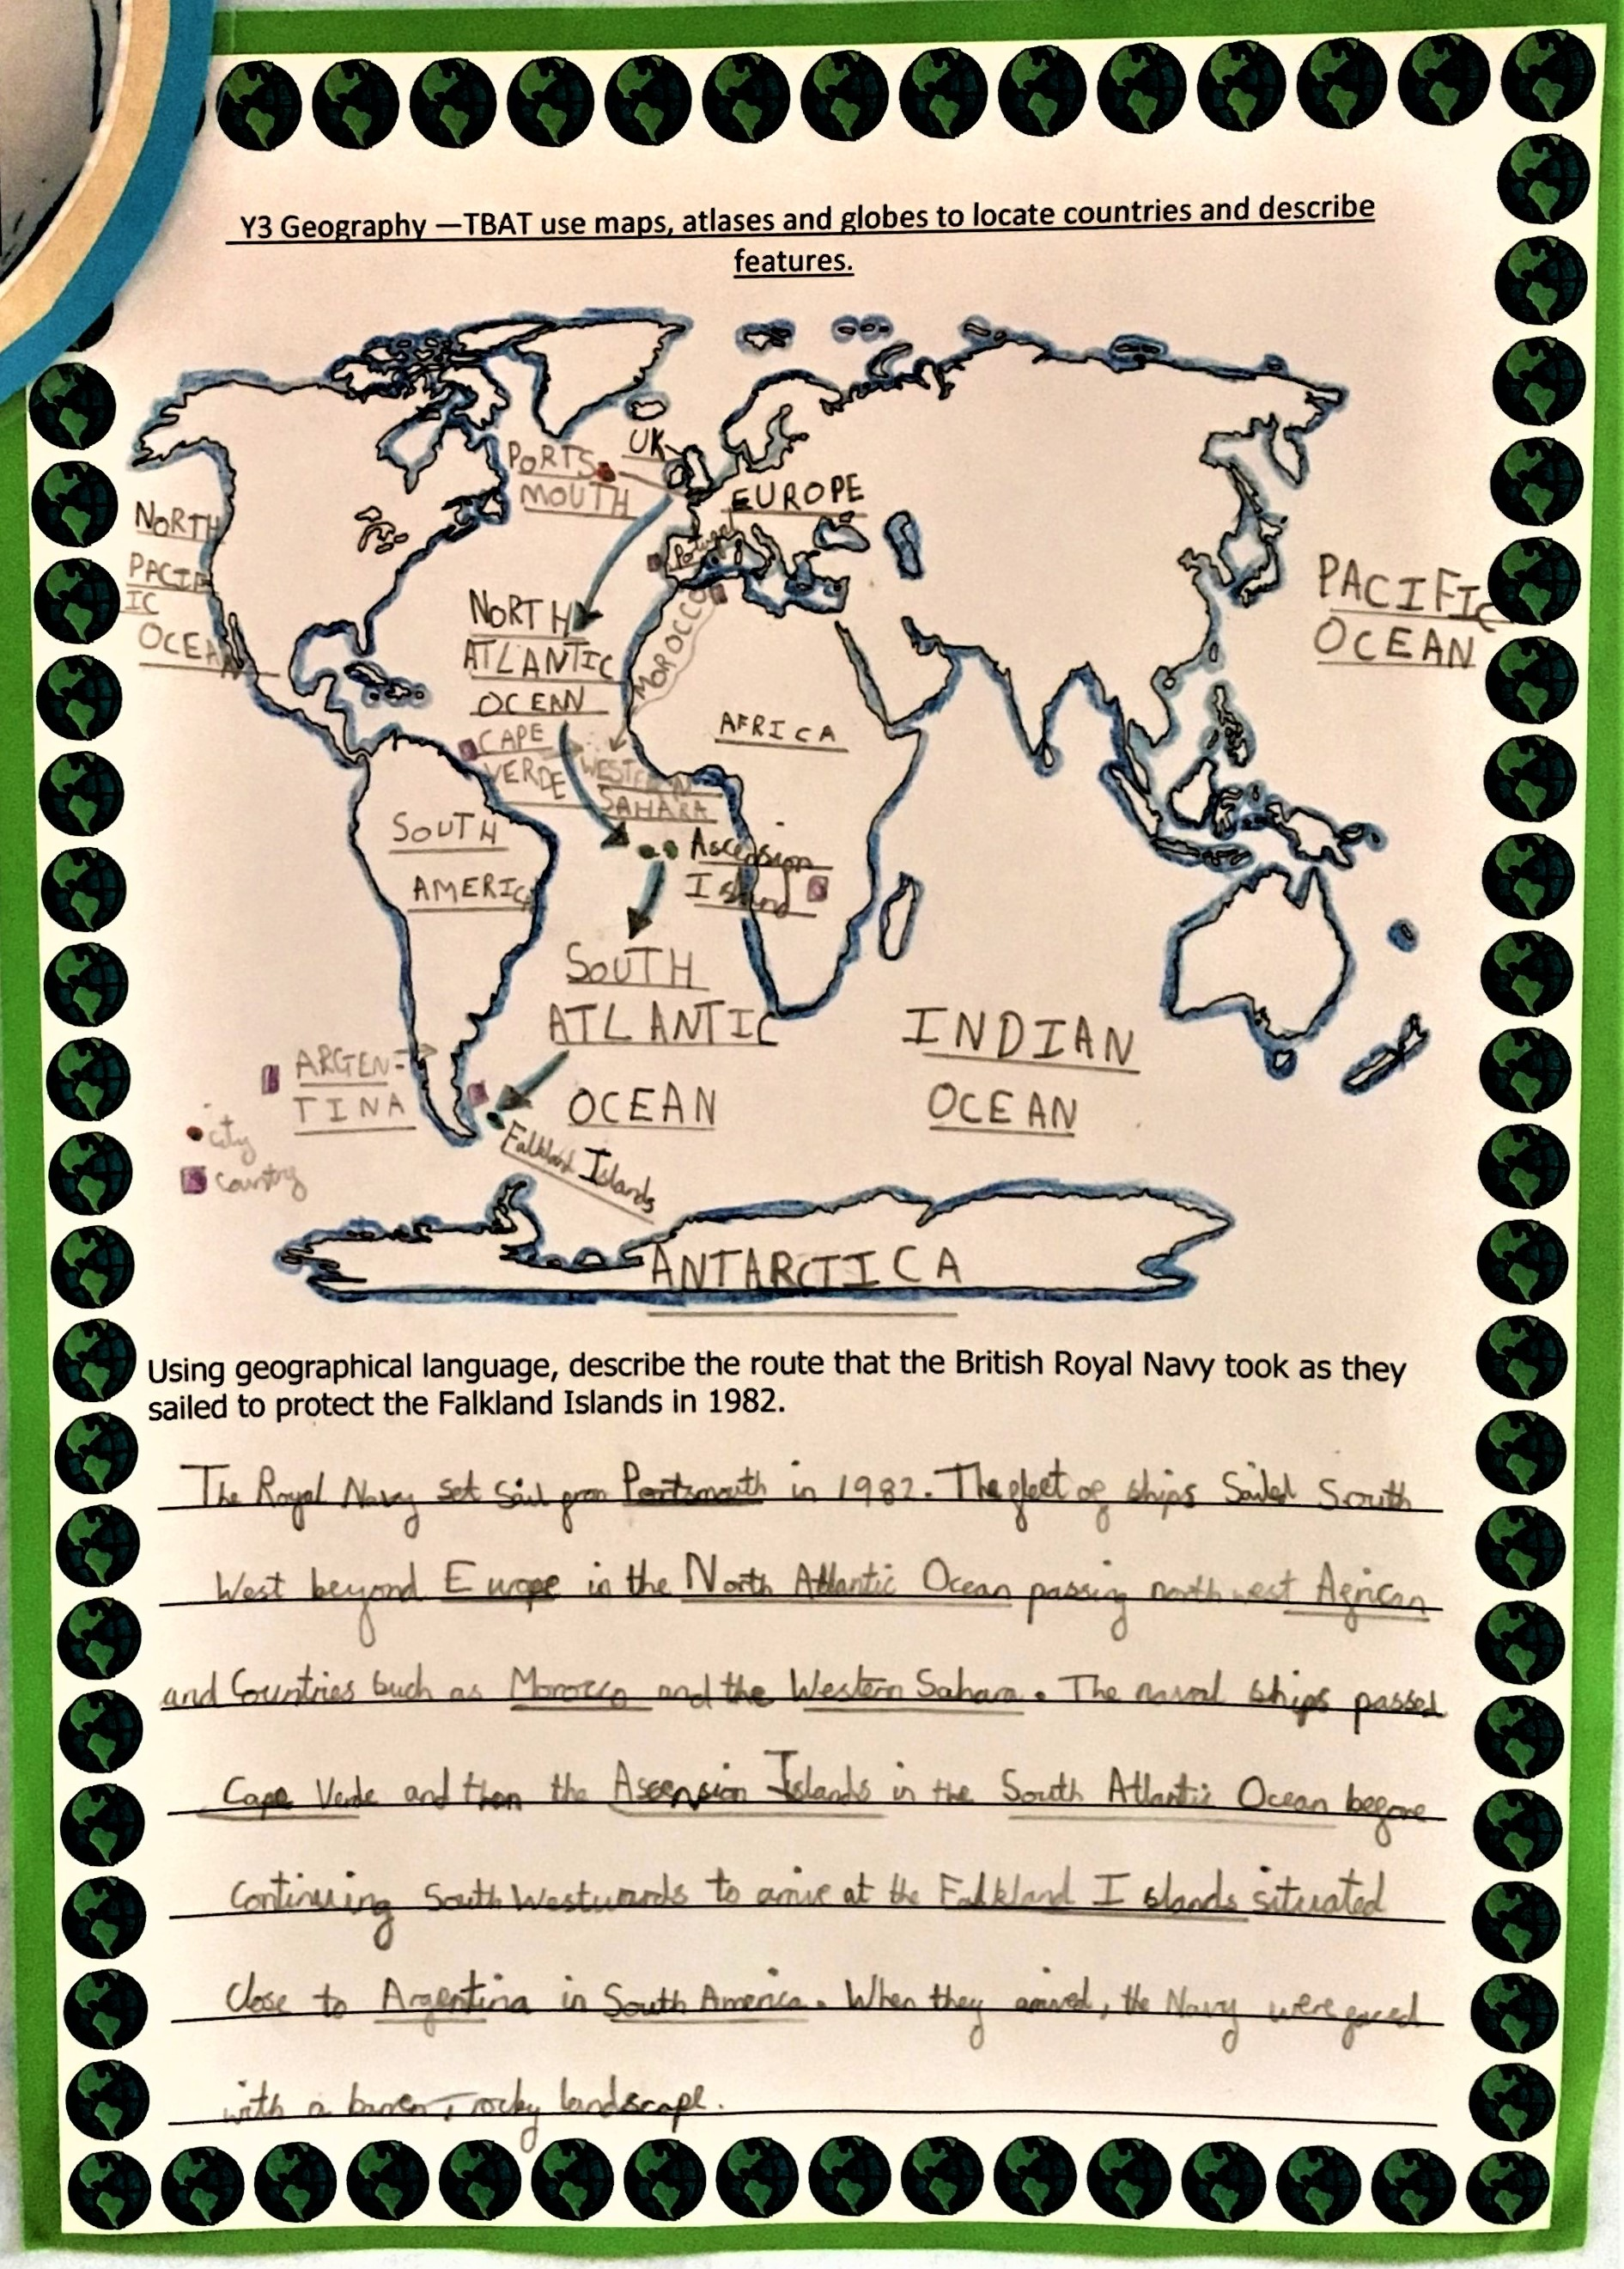

Year 3:
Children have an increasing knowledge of our world and can locate and name the world’s countries.

Key Vocabulary
Country, North, East,
South, West

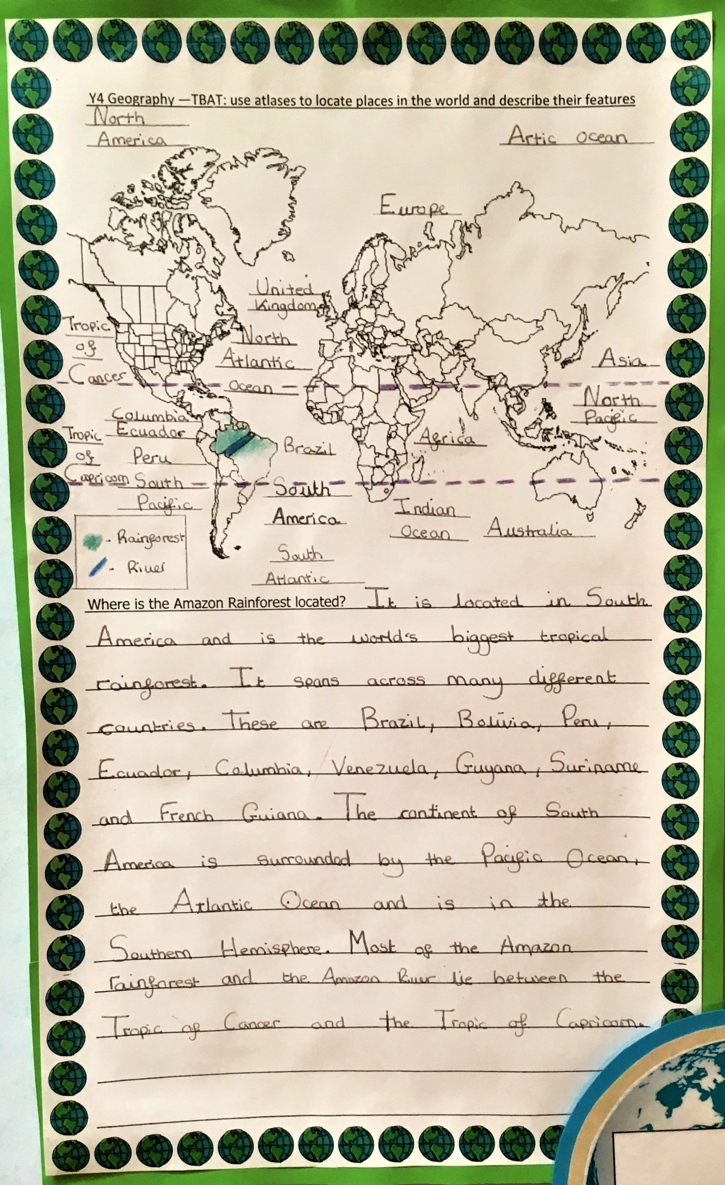

Year 4:
Children have a detailed knowledge of the world and can identify North and South America.

Key Vocabulary
Tropic of Cancer,
Tropic of Capricorn

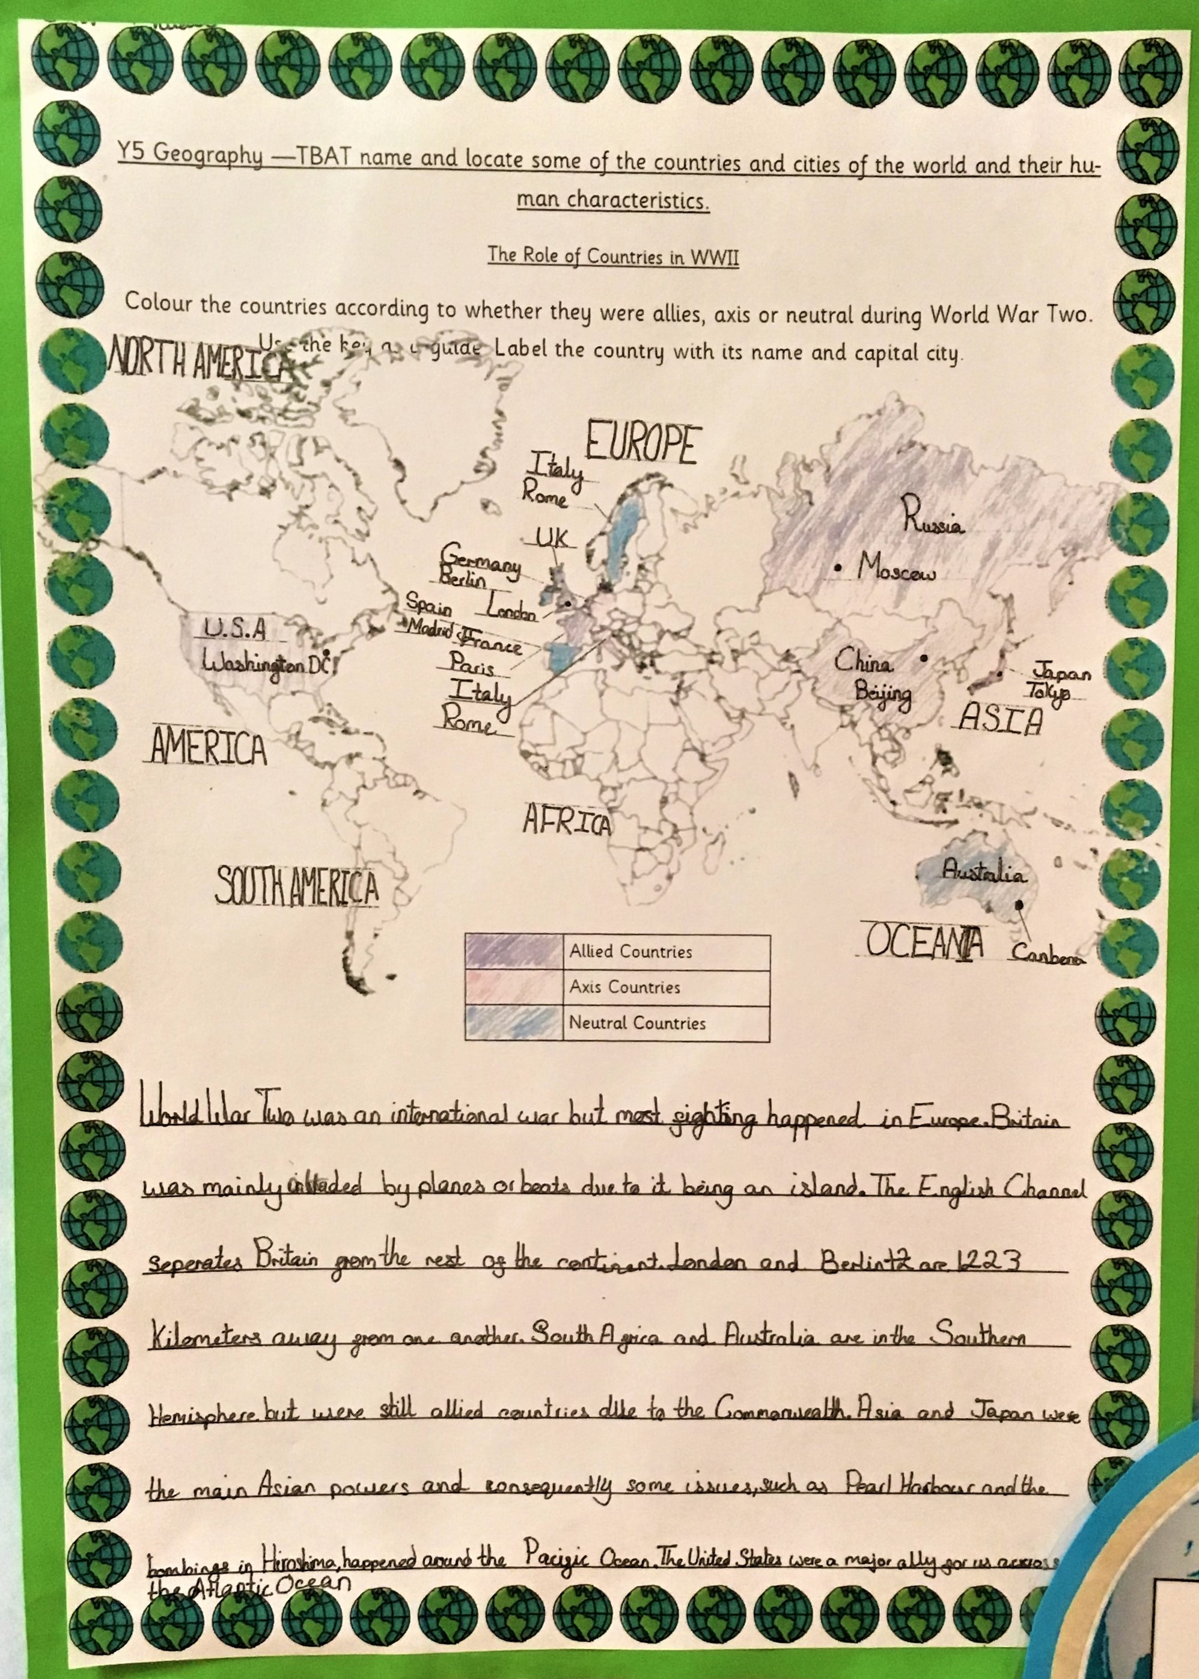

Year 5:
With a broad knowledge
of the world, children
can locate and name some European countries and their capital cities.

Key Vocabulary
Capital city,
International

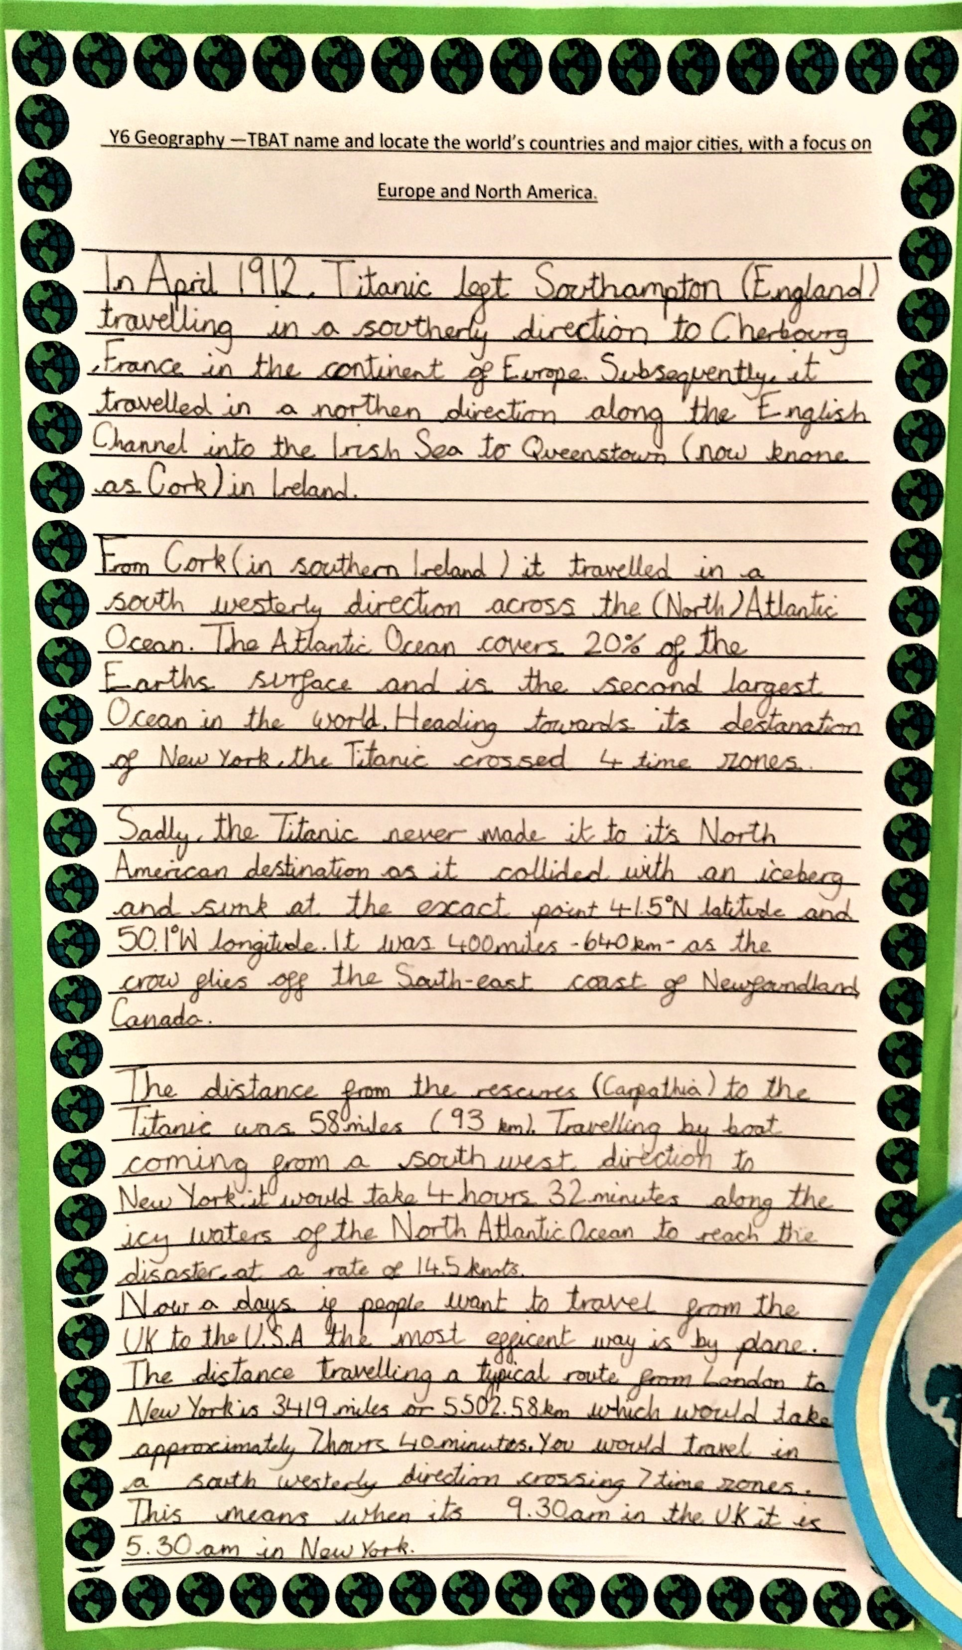
Year 6:
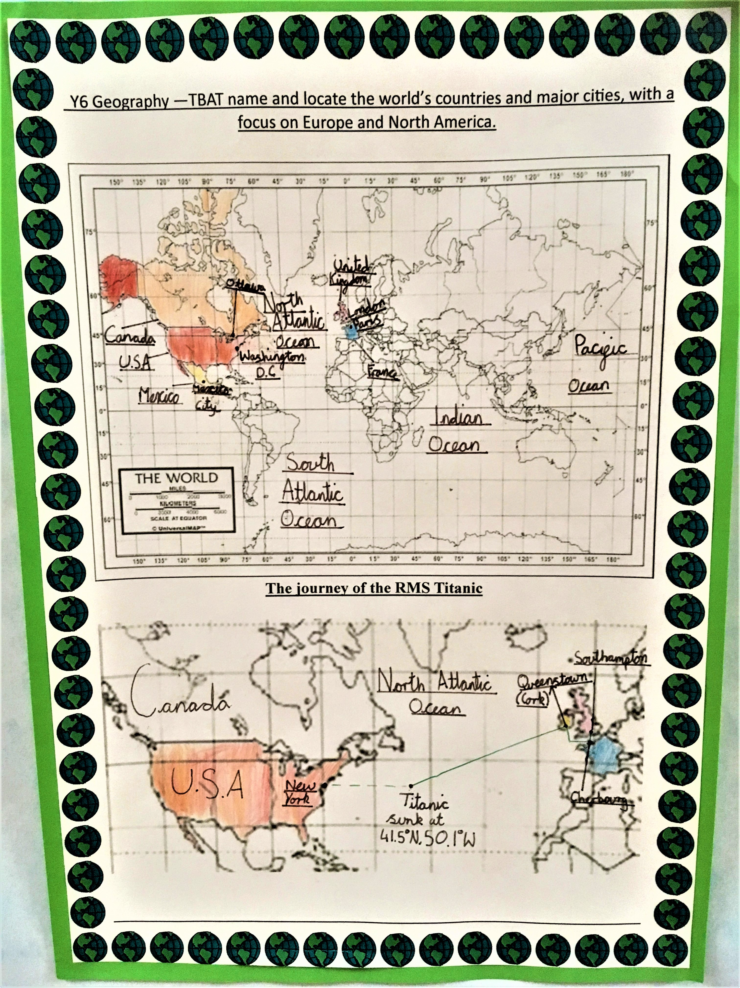
With a broad and detailed knowledge of the world, children can locate and name some countries and major cities of the world and understand some of their human and physical characteristics

Key Vocabulary
Longitude, Latitude

