

|  |
| --- |
| **Key Concepts/Features** |
| The **Vikings** were **invaders** and **settlers** who came from **Scandinavia** and travelled by **longboats** as far as North America in the west and Central Asia in the east from about 700 AD to 1100. The word “Viking” meant “pirate raid” in the Old Norse language. From the end of the 8th century onwards, the Vikings began to attack England. The strength of the army grew, and in 866 the Vikings captured the city of**York**. The last great Viking invasion force was defeated in battle at **Stamford Bridge** in 1066. Vikings settled all across the country, but the densest population was found in **Yorkshire**, where they had their capital city. It is here in the **Jorvik** region where we see more Viking place names than anywhere else. They end with the suffixes -by, -thorp(e), - thwait(e), -toft(s) and -ness. |

|  |  |
| --- | --- |
| **Timeline** | |
| **AD 700** | The Viking age begins. |
| **AD 793** | First invasion by the Vikings. They raided monasteries on the coast including Lindisfarne, off the coast of Northumbria. |
| **AD 794** | First raids on Scotland and Ireland. |
| **AD 865** | Great Viking army from Denmark invades England |
| **AD 866** | Danes capture York (which the Viking called Jorvik) and make it their kingdom (land ruled by a king) |
| **AD 876** | Vikings from Denmark, Norway and Sweden settle permanently in England. |
| **AD 886** | King Alfred the Great defeats the Vikings but allows them to settle in Eastern England. |
| **AD 954** | Eric Bloodaxe, the last king of Jorvik, is thrown out of York |
| **AD 1001** | Vikings land in America and establish a settlement. |
| **AD 1014** | King Canute (Cnut) of Denmark becomes King of England. |
| **AD 1066** | Battle of Hastings occurred; William I (the Conqueror) crowned King of England. |
| **AD 1100** | End of the Viking age. |

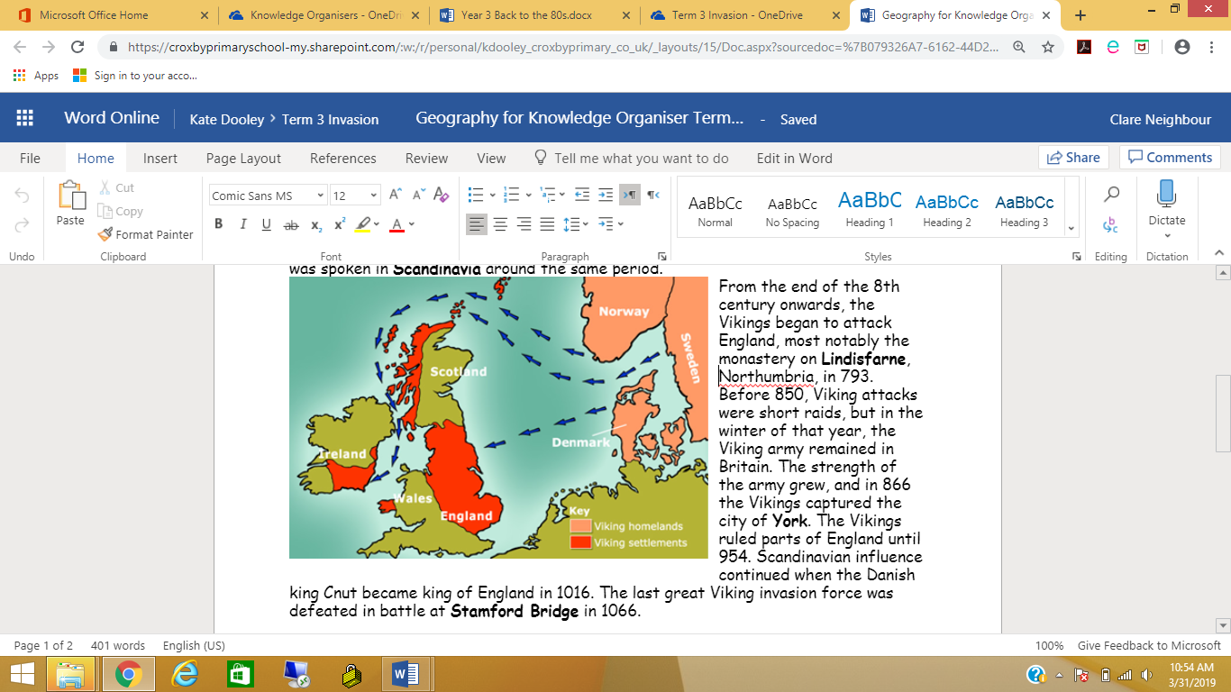

|  |  |
| --- | --- |
| **Key Vocabulary** | |
| **Jorvik** | The name given to the city of York by the Vikings |
| **Scandinavia** | An area in northern Europe that includes countries such as Norway, Sweden and Denmark |
| **Monastery** | A place where monks live |
| **Monks** | Men living in a religious community |
| **Invaders** | People who attack and raid a country or place. |
| **Region** | An area of land that has common features. A region can be defined by natural or artificial features |
| **Longboats** | A type of Viking warship |
| **Settlement** | Any form of human dwelling |
| **Runes** | Scripture or writing carved using tools, into stone, bone, wood and metal |
| **Odin, Loki, Thor, Frey and Freya** | The main Viking gods |

