Timeline
1570 | Guy Fawkes was born in York, England
November 5th 1605 | Guy Fawkes planned to blow up the Houses of Parliament in London.
2nd September 1666 | A fire starts in a bakery on Pudding Lane, London
4th September 1666 | Houses are pulled down in an attempt to stop the fire
6th September 1666 | The fire starts to burn more slowly as the wind dies down
7th September 1666 | The fire is finally under control

Key Locations
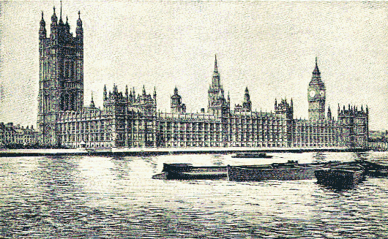
The Houses of Parliament, London.
This is where the government do all their work.
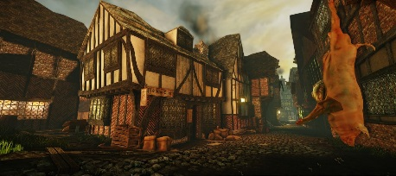

Pudding Lane, London.
This is where the fire started in London.
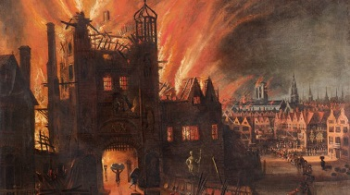
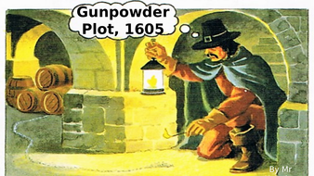
Key Vocabulary
London | The capital city of England
Plot | A secret plan to do something that is illegal or wrong
Executed | To kill someone as a punishment for a serious crime
Explosives | A substance or device that can cause an explosion
Government | The group of people who are responsible for running the country
Gunpowder | An explosive substance used to make fireworks or explosions.
Treason | The crime of betraying your country
Bakery | A place where bread or cakes are made and sold
Diary | A book with pages for each day of the year in which to write about events
Flammable | Something which easily sets on fire
Eye witness | A person who has seen something and can give a description of it
Embers | Small pieces of glowing coal or wood in a dying fire
Key People
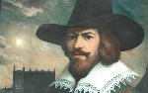 | Guy Fawkes  He plotted to use explosives to destroy the Houses of Parliament and King James 1.
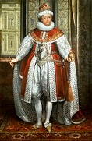 | King James 1  He was the monarch on the throne at the time of Gunpowder Plot.
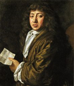 | Samuel Pepys  Samuel Pepys survived the Great Plague of 1665.  He also saw the Great Fire of London in 1666. It destroyed 13,000 houses.  We know lots about these two events from his diary.
Key Concepts/Features
Guy Fawkes planned to blow up the Houses of Parliament using gunpowder. However the plot was discovered by King James I and was unsuccessful. We celebrate this event on Bonfire Night.
Guy Fawkes Poem:
Remember, remember the fifth of November,
Gunpowder, treason and plot.
We see no reason
Why Gunpowder treason
Should ever be forgot
In 1666, a huge fire that started in a tiny bakery burned down most of London – because it was so big, it was called the Great Fire of London.

The fire lasted four days, and burned down over 13,000 homes. There are a lot of reasons why the fire was so large, mostly to do with the way houses were built – a lot of them were made from wood, and were very close together. Samuel Pepys wrote a diary which explains what happened during this time.

