Key Concept/ Features
In 55 BC, the Roman General Julius Cesar wanted to make Britain part of Rome’s empire. He was unsuccessful and returned in 54 BC but lost again. In AD 43, Claudius (emperor) invaded with four legions and conquered Southern Britain.
Some Celts made friends with the Romans in return for keeping their kingdom. They kept Roman laws and paid tax. Other British leaders fought the Romans. The best British leader was Carctacus but he was beaten in AD 51 and taken as a prisoner.

When the Romans came to Britain, they brought their way of life with them. Over time, the people of
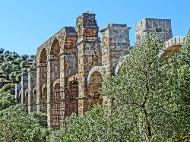
Britain and Romans mixed and Britons took on the Roman lifestyle. They built houses, shops, meeting spaces, temples and bath houses. The Romans were good at building roads and bridges. They built arches into big buildings and aqueducts to supply towns with water. They ensured towns were clean and reduced chances of disease. They also introduced Latin to Britain and increased Literacy.

Roman Inventions:
Concrete, newspapers, calendars, medicine, aqueducts, roads, sewers, central heating,
census, laws and the welfare state.
Key Vocabulary | Definition
Aqueduct | A system of pipes and channels used to bring water into towns
arbarian | A person who lived outside the Roman Empire, seen by Romans as violent and uncivilised
Basilica | A large building where town business was carried out
Celts | People who lived in Europe, including Britain, who fought the Romans
Empire | A large area with many people, ruled by one strong leader, called an emperor
Iceni Tribe | A Celtic tribe led by Boudicca into a rebellion against the Romans
Mosaic | A pattern made from coloured pieces of stone and pottery
Picts | People who lived in Scotland
Republic | A country without a King/Queen/Emperor – The Roman republic was rules by the elected Senate
Senate | The Roman government made up of senators
Taxes | Money or items taken by the government from people, to pay for things like the army, wars, palaces and building roads
Timeline
AD 43 | Romans invade Britain
AD 60 | Battle of Watling – the Romans defeat the Inceni tribe (Boudicca)
AD 73 | Romans conquer Wales
AD 79 | Romans attempt to conquer Scotland
AD 122 | Work on Hadrian’s Wall begins
AD 138 | Antonine Wall is built
AD 216 | Britain divided into two provinces
AD 388-400 | Romans begin to leave Britain
AD 410 | Last Romans leave Britain
Key People
Julius Cesar
Claudius | 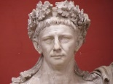
Augustus | 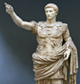
Hadrian | 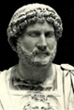
Key Locations
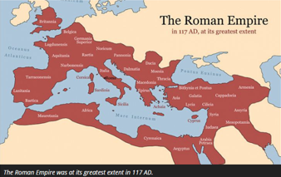
The following cities were important population centres during the time of the Roman Empire.
Hadrian’s Wall
Rome

