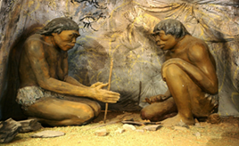
Key Concepts/Features
The Stone Age is the name given to the earliest period of human culture, when stone tools were first used. The Stone Age ended when men began smelting metal. The Stone Age is divided into three periods; the Paleolithic (old Stone Age), Mesolithic (middle Stone Age) and the Neolithic (new Stone Age). Paleolithic and Mesolithic people were nomadic hunter-gatherers. They moved frequently following the animals that they hunted and gathering fruits and berries when they could.
Timeline
2,000,000 BC | The first real humans (Homo habilis) appear – They used simple stone tools, which they made, and built shelters
1,600,000 BC | ‘Homo erectus’ appears – They were skillful hunters and killed animals to eat using spears
500,000 BC | The first members of the Homo genus live in Britain
200,000 BC | Great sheets of ice cover Britain and food becomes scarce – Early humans are forced to leave
100,000 BC | Neanderthals make it to Britain, coping with the cold weather by living in caves and making warm clothes from animal skins
35,000 BC | Homo sapiens arrive in Europe and Neanderthals die out
12,000 BC | The earliest humans that are direct descendants of some of the current population arrive in Britain and woolly mammoths die out in Britain
10,000 BC | ‘The Ice Age’ comes to an end in Britain – This marks the beginning of the Mesolithic period
3,000 BC | The first part of Stonehenge is built

Key Concepts/Features
The first Homo sapiens are believed to have been the Neanderthals. Neanderthals were around five to six feet in height. They had thick sturdy bones, and muscular shoulders, legs, arms and necks. Neanderthals also had large brains. Neanderthals learned to create specialised cutting and scraping tools by chipping away at the edge of a rock.
Key Locations
Caves of Lascaux
Early humans expressed their struggles and successes by creating cave art. The famous cave paintings at Lascaux (France) are about 18,000 years old. Stone Age artists also created sculptures from clay, ivory, bone or carved stone.
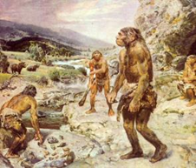

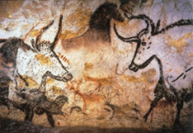

Key Vocabulary
Flaking | A process of shaping stone by chipping pieces off the edges
Homo erectus – | Skillful hunters which lived 1,600,000 BC
Hunter-Gatherer | A person who meets their needs by hunting animals and gathering plants
Microlith | Small, sharp stones used as arrow and spear heads
Neolithic Era | The last period of the Stone Age when humans began to develop agriculture and use tools and weapons
Mesolithic Era | The period from the last Ice Age to the start of farming
Nomadic | Moving around a lot
Paleolithic Era | The earliest part of the Stone Age characterised by tools made of crudely chipped stone and by cave art
The term ‘lithic’ comes from the Ancient Greek word for stone or rock.

