Measures conversions
3 ½ cm | 35 mm
1.09 m | 109 cm
3.07 km | 3070 m
1 mile | 1.6 km
1 km | 0.625 km  (3/8 mile)
1 inch | 2.5 cm
1 foot | 30cm
5 miles | 8 km
0.902 L | 902 ml
1 pint | 570 ml
1 gallon | 4.5 L
1.75 pints | 1 L
0.08 kg | 80 g
1 pound | 450 g
2.2 pounds | 1 kg
1 stone | 6.3 kg
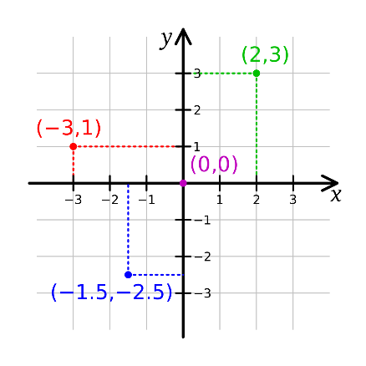
Term | Definition | Example
Factor | A number that divides exactly in to another number | Factors of 12 = 1, 2, 3, 4, 6, 12
Common factor | Factors of two numbers that are the same | Common factors of 8 and 12 = 1, 2, 4
Prime number | A number with only 2 factors: 1 and itself. | 2, 3, 5, 7, 11, 13, 17, 19 …
Composite number | A number with more than two factors | 12 (it has 6 factors)
Prime factor | A factor that is prime | Prime factors of 12 = 2, 3
Multiple | A number in another number’s times table | Multiples of 9 = 9, 18, 27, 36…
Common multiple | Multiples of 2 numbers that are the same | Common multiples of 4 and 6 = 12, 24…
Square numbers | A result when a number has been multiplied by itself | 25 (5² = 5 x 5)  49 (7² = 7 x 7)
Cube numbers | The result when a number has been multiplied by itself 3 times. | 8 (2³ = 2 x 2 x 2)  27 (3³ = 3 x 3 x 3)

Co-ordinates
Read co-ordinates along the x axis (horizontal) first, then the y axis (vertical) E.g. (3, -4) = go right 3, down 4.

Roman Numerals
I | V | X | L | C | D | M
1 | 5 | 10 | 50 | 100 | 500 | 1000
VII | XIX | XLVII | LXVI | IC | DCCLVI | MMCLXIV
7 | 19 | 47 | 66 | 99 | 756 | 2164

