Spanish Progression Booklet
To express ideas clearly.

As linguists...

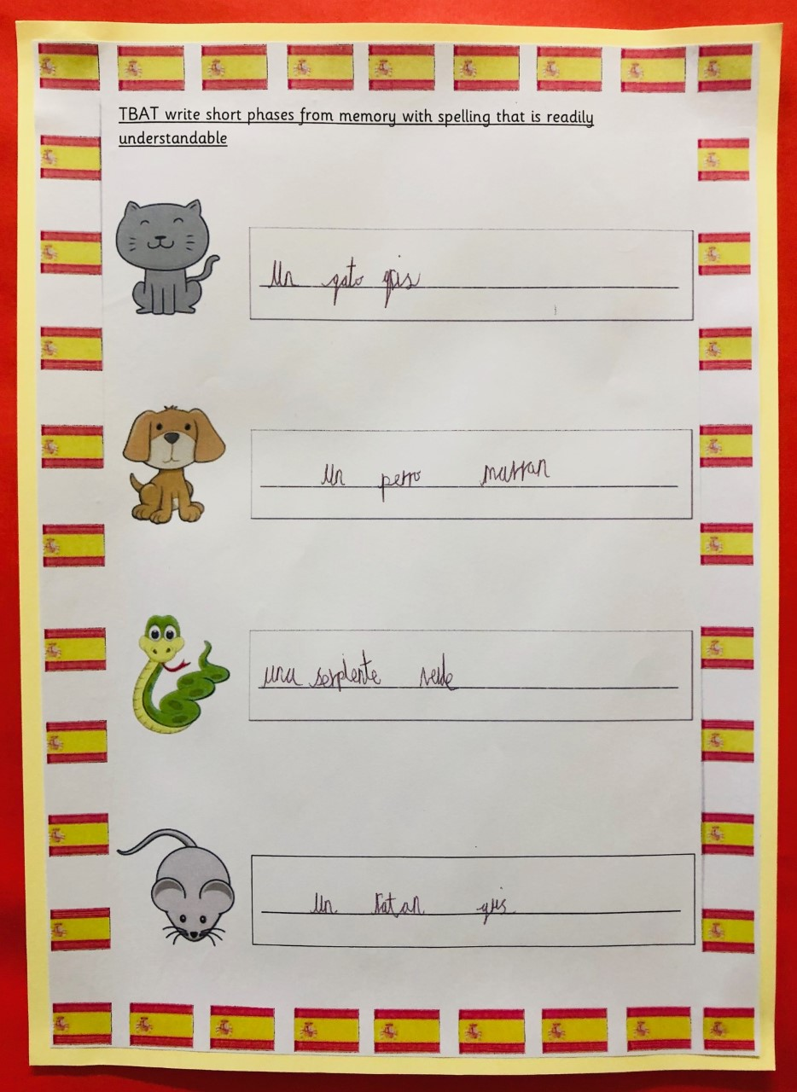

Year 3:
Children can write a few short phrases using familiar expressions.

Key Words
animales, colores

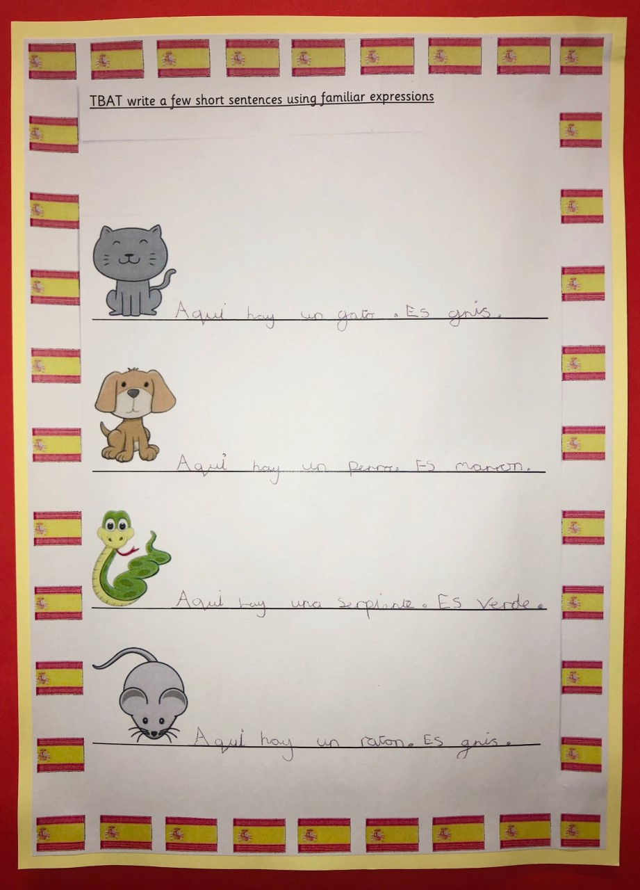

Year 4:
Children can write short sentences from memory with spelling that is readily understandable.

Key Words
aqui hay

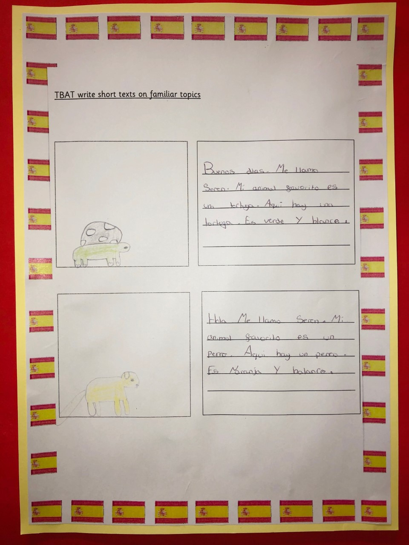
Year 5:
Children are beginning to write short texts on familiar topics.

Key Words
Mi animal
favorito es...

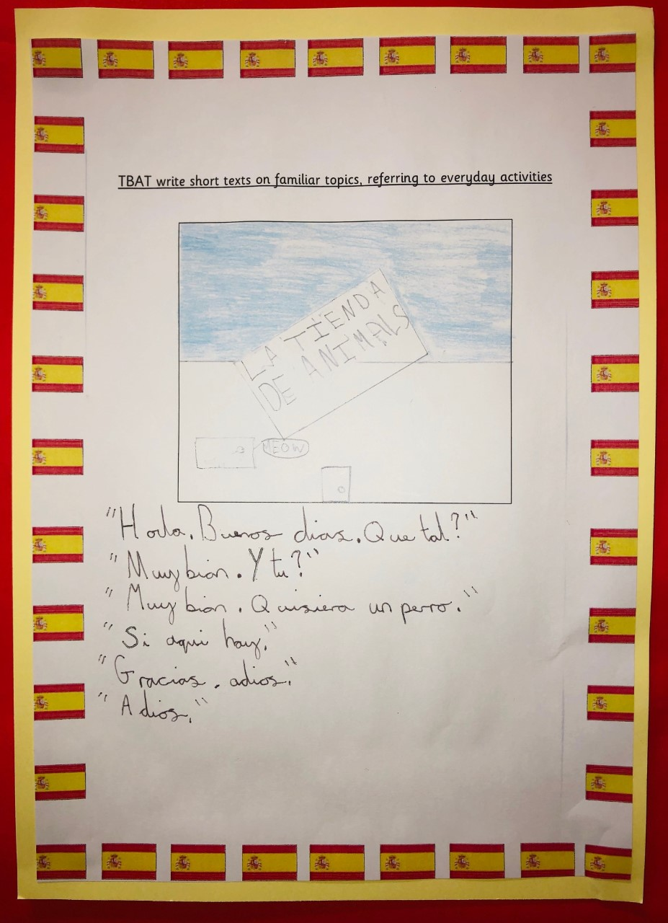

Year 6:
Children can confidently write a short text on a familiar topic referring to everyday activities.

Key Words
buenos dias

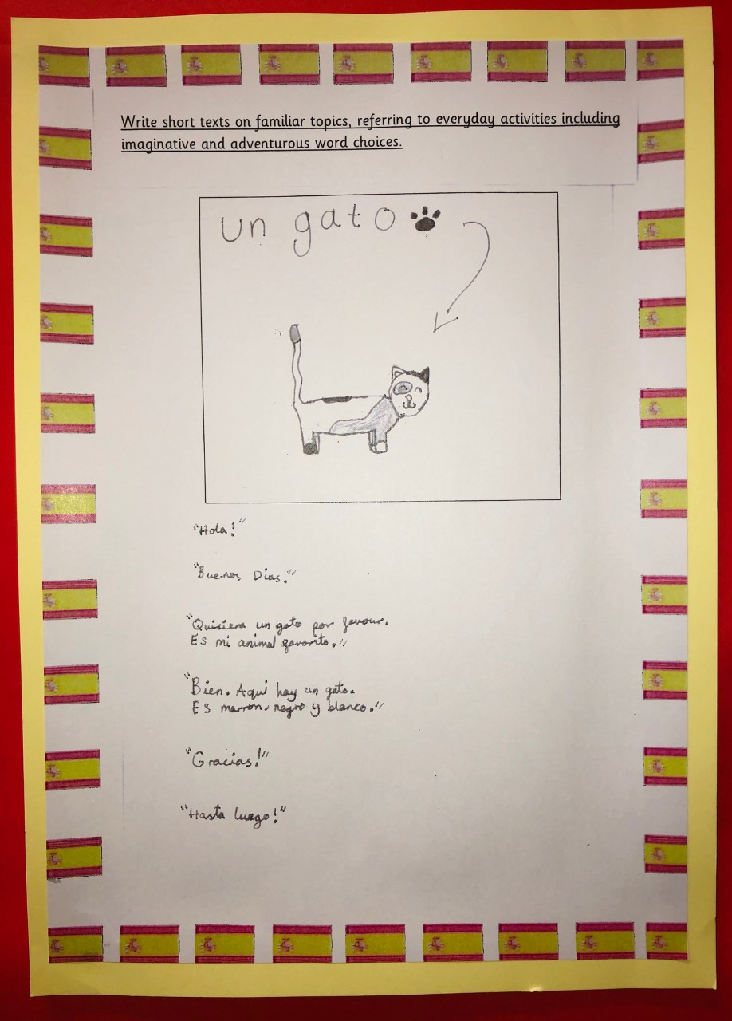

Mastery:
Children have an in depth knowledge of a familiar topic and can write a short text referring to a variety of everyday activities.

Key Words
hasta luego

