Timeline
1981 | Prince Charles married Princess Diana.
1982 | Prince William was born.
1984 | Prince Harry was born.
1997 | Princess Diana died from a car crash in Paris.
2011 | Prince William married Catherine, Duchess of Cambridge.
2012 | Queen Elizabeth II Diamond Jubilee.
2013 | Prince George is born.
2015 | Princess Charlotte is born.
2018 | Prince Louis was born.
2018 | Prince Harry married Meghan Markle.
2019 | Archie Harrison Mountbatten-Windsor is born.

Key People
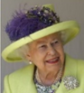 | Queen Elizabeth II  The Queen of the United Kingdom of Great Britain and Northern Ireland.
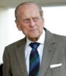 | Prince Phillip  Married to Queen Elizabeth II.
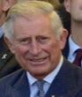 | Prince Charles  Queen Elizabeth II and Prince Philip’s son. Father to Prince William and Prince Harry.
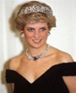 | Princess Diana  Prince Charles’ first wife and mother to Prince William and Prince Harry.
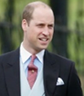 | Prince William  Son of Prince Charles and Princess Diana. Married Catherine (Kate) Middleton.
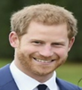 | Prince Harry  Son of Prince Charles and Princess Diana. Married Meghan Markle.
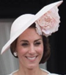 | Catherine (Kate) Middleton  Married Prince William
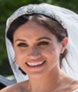 | Meghan Markle  Married Prince Harry.

Key Locations
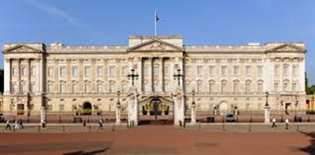  Buckingham Palace, London | 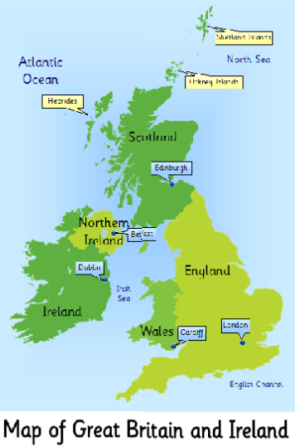
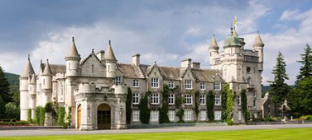
Balmoral Castle. Scotland
Key Vocabulary
Human features | Human features are things that are built by humans such as bridges and roads.
Physical features | Physical features show natural objects such as mountains and rivers.
Environment | All the surroundings on Earth are called the environment. The environment includes everything living and everything non-living.
Land use | When an area of land is used to meet the wants and needs of people.
Rural | These are places in the countryside.
Urban | Towns and cities are called ‘urban’
Monarch | Head of state. This could be a king, queen, or emperor.
King | The male ruler of a state who has usually inherited the position.
Queen | The female ruler of a state who has usually inherited the position.

