Key Vocabulary
Term | Definition | Example
Odd numbers | A whole number that cannot be divided by 2. | 1, 3, 5, 7, 9 …
Even numbers | A whole number that can divided by 2. | 2, 4, 6, 8 …
Pair | A group of two. | 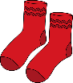
Array | An array is a set of numbers or objects placed in rows or columns. | 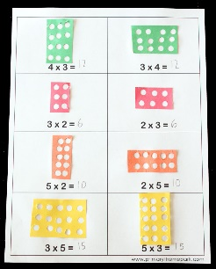
Less than | A number is smaller than another. | 12 < 14
Greater than | A number is bigger than another. | 14 > 12

Time
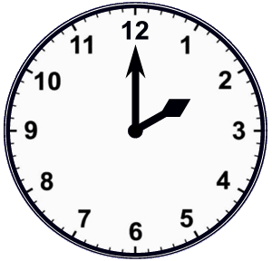 | 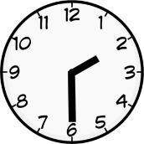
2 o’clock | Half past 2

Month
January
February
March
April
May
June
July
August
September
October
November
December

Days of the week
Monday
Tuesday
Wednesday
Thursday
Friday
Saturday
Sunday

2D shapes
Shape |  | Number  of sides | Number of  corners
triangle | 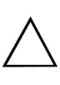 | 3 | 3
Square |  | 4 | 4
Circle | 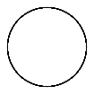 | 1 | 0
Rectangle |  | 4 | 4
Pentagon |  | 5 | 5
3D Shapes |  | Faces | Edges
Cuboid |  | 6 | 12
Pyramid | 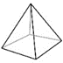 | 5 | 8
Cube | 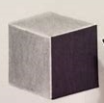 | 6 | 12
Sphere |  | 1 | 0
