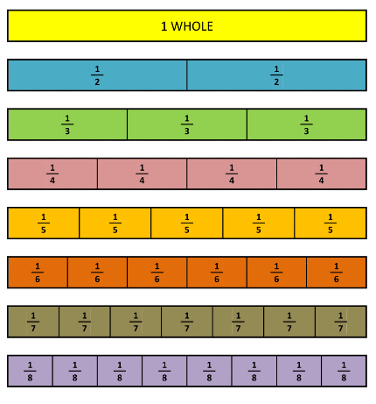
Key Vocabulary
Term | Definition | Example
Integer | A number which is not a fraction; a whole number. | 1, 2, 3, 4, 5 …
Positive | Any number above 0 | 1, 2, 3, 4, 5 …
Multiple | A number in another number’s times table. | Multiples of 9 are  9, 18, 27, 36 …
Product | A quantity obtained by multiplying quantities together. | 3 x 4 = 12  5 x 7 = 35
Array | An array is a set of numbers or objects placed in rows or columns. | 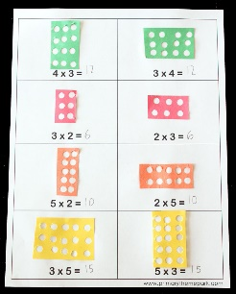
Month |  | Days
January |  | 31
February |  | 28 (29 in a leap year)
March |  | 31
April |  | 30
May |  | 31
June |  | 30
July |  | 31
August |  | 31
September |  | 30
October |  | 31
November |  | 30
December |  | 31
1 year = 365 days = 52 weeks
1 leap year = 366 days
Fortnight = 2 weeks
60 seconds | 1 minute
60 minutes | 1 hour
Noon | 12:00 in the middle of the day.

Shape vocabulary
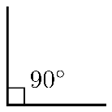  Right angle | Symmetrical  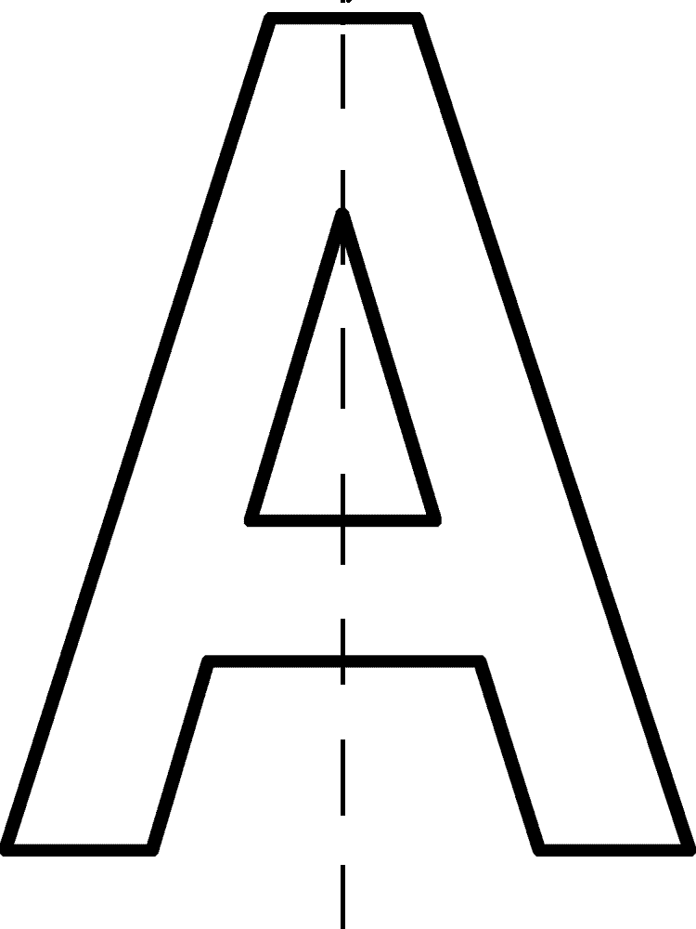
Perpendicular  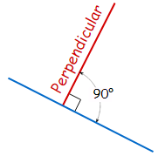 | Parallel
Horizontal | Vertical
Measures Conversions
Length
1.5 kilometre (km) | 1500 metres (m)
1.5metre (m) | 150 centimetres (cm)
Capacity
1.5centimetre (cm) | 15 millimetres (mm)
1.5Litre (L) | 1500 millilitres (ml)
Mass
1.5 Kilogram (kg) | 1500 grams (g)

2D shapes
shape | Number of sides
triangle | 3
Square, rectangle | 4
Pentagon | 5
Hexagon | 6
Octagon | 8
Nonagon | 9
Decagon | 10
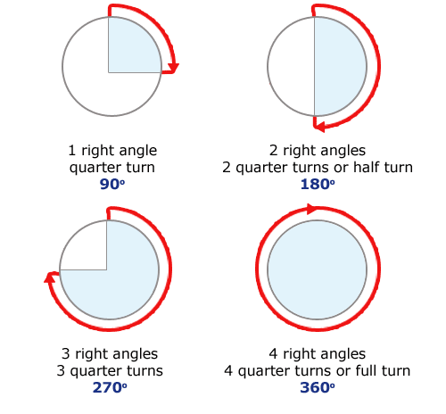
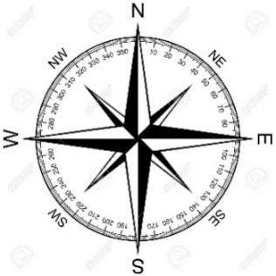

Roman numerals
I | II | III | IV | V | VI | VII | VIII | IX | X | XI | XII
1 | 2 | 3 | 4 | 5 | 6 | 7 | 8 | 9 | 10 | 11 | 12

