Key Vocabulary

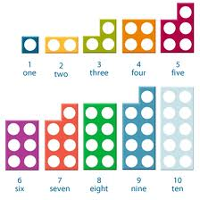

|  |  |  |  |
| --- | --- | --- | --- |
| **2D shapes** | | | |
| **shape** | | **Number of**  **sides** | **Number of corners** |
| triangle | Image result for triangle | 3 | 3 |
| Square | Image result for square | 4 | 4 |
| rectangle | Image result for rectangle | 4 | 4 |
| circle | Image result for circle | 1 | 0 |



  
  
  

